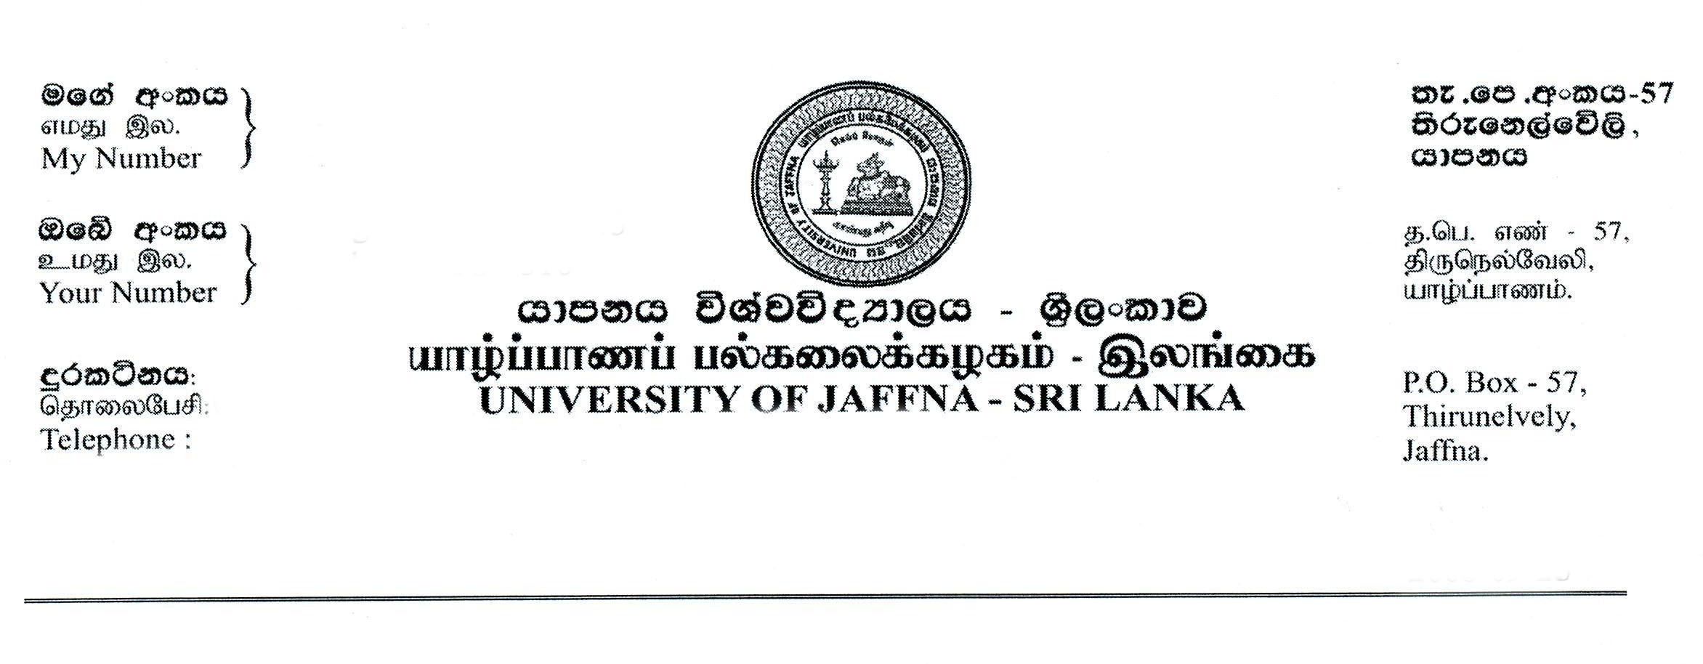
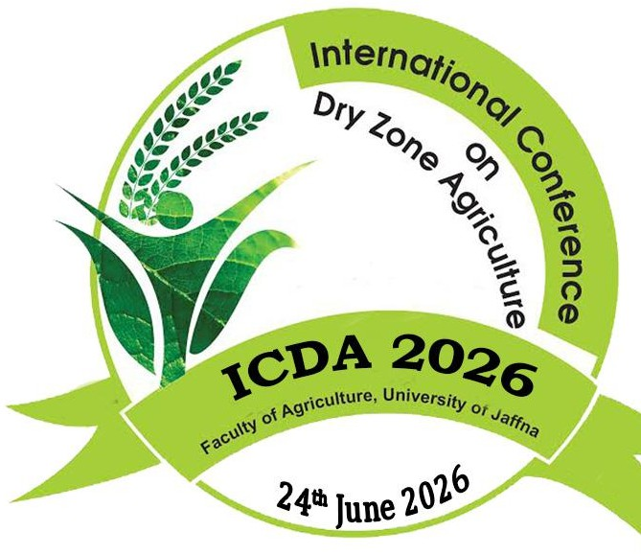
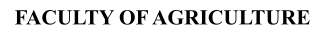
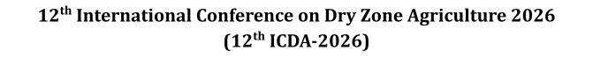


Author(s) Consent form- ICDA 2026

- I/We undersigned declare and acknowledge that:
  - I/We have authored/co-authored or supervised the research work entitled
v The consumer awareness and perceptions of chocolate vs choco products in Sri Lankan market and its impact on consumer behaviour

  - I/We agreed to submit the above research work to the 12th International Conference on Dry Zone Agriculture (ICDA) 2026 organized by the Faculty of Agriculture, University of Jaffna
  - The abstract submitted for ICDA 2026 reports original research carried out by the authors mentioned and has not been published or submitted for publication elsewhere. Further I/we understand that the editor’s decision is final on the outcome of the publication.
  - If the manuscript is accepted for an oral presentation, Faculty of agriculture, University of Jaffna has the right to publish in the 12th ICDA proceeding
  - The research remains the intellectual property of the authors, who are entitled to submit it for the publication in other journals or Journal of Dry Zone Agriculture published by Faculty of Agriculture, University of Jaffna

- Preferred sub theme(s) for submission:
1. | Click here to enter text
2. | Click here to enter text.
3. | Click here to enter text.

- Names and signatures of authors in the order they appear in the abstract:
 | Authors Name | Signature | Date
1. | M.R.S.Perera |  | 2025.12.30
2. | U.B.E. Sasanka | 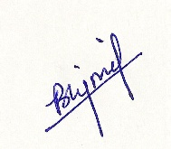 | 2025.12.30
3.
4.
Add additional authors by insertion

- Contact details of Co-responding author:
Full Name: | Maddhumage Ruwanthika Sandali Perera
Official Address: | 121/ Sadhdhatissa Mawatha, Kindelpitiya, Bandaragama
Email Address: | mrsperera@std.agri.sab.ac.lk
T. Number (Mobile): | 0773922524
Signature:

Full Name:
Official Address:
Email Address:
T. Number (Mobile):
Signature:

All authors must sign the consent form for the consideration of the research work to ICDA 2026

