Author(s) Consent form- ICDA 2026

A) I/We undersigned declare and acknowledge that:
- I/We have authored/co-authored or supervised the research work entitled
Seasonal Dynamics and Antimicrobial Susceptibility Patterns of Bovine Mastitis in Dairy Cattle of Anuradhapura District, Sri Lanka

- I/We agreed to submit the above research work to the 12th International Conference on Dry Zone Agriculture (ICDA) 2026 organized by the Faculty of Agriculture, University of Jaffna
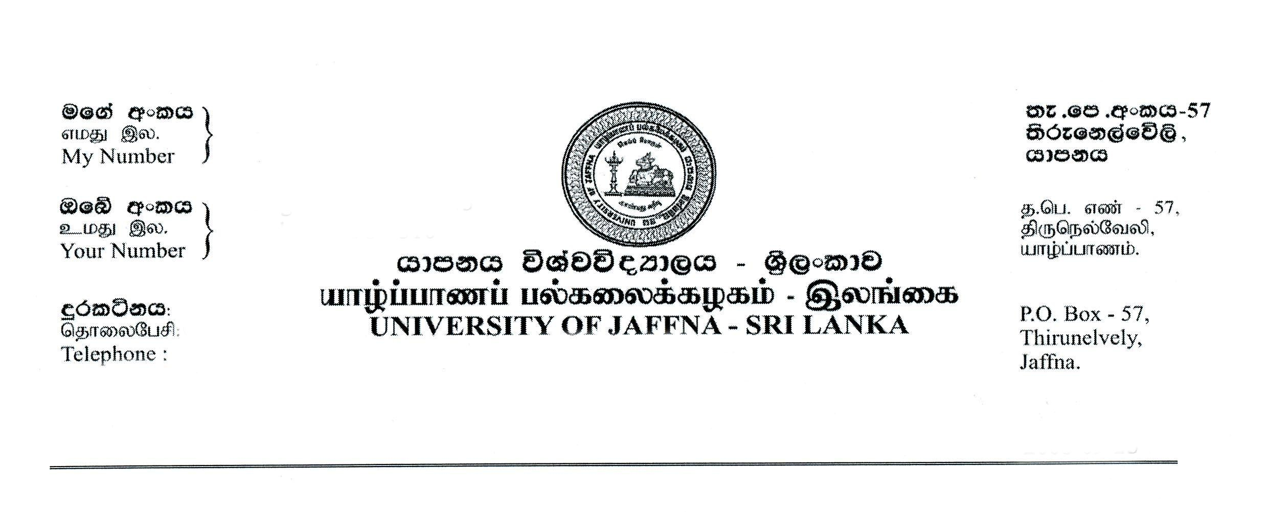
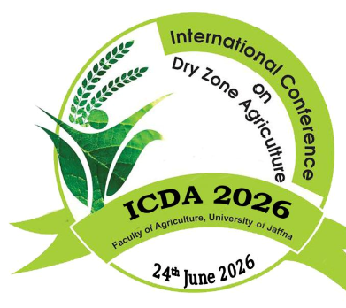

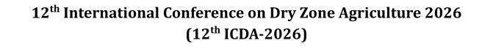

- The abstract submitted for ICDA 2026 reports original research carried out by the authors mentioned and has not been published or submitted for publication elsewhere. Further I/we understand that the editor’s decision is final on the outcome of the publication.

- If the manuscript is accepted for an oral presentation, Faculty of agriculture, University of Jaffna has the right to publish in the 12th ICDA proceeding
- The research remains the intellectual property of the authors, who are entitled to submit it for the publication in other journals or Journal of Dry Zone Agriculture published by Faculty of Agriculture, University of Jaffna

- Preferred sub theme(s) for submission:
1. | Animal Science and Aquaculture
2.
3.

ICDA-2026 Secretariat, Faculty of Agriculture, University of Jaffna, Ariviyal Nagar, Kilinochchi 44000, Sri Lanka.
TP+94(0) 77 825 2821: /+94(0) 77 326 4666/+94(0) 77 638 1736/+94(0) 77 941 8078
Fax: +94 (0) 212060175 / Email: icda@univ.jfn.ac.lk / Web: https://www.juice.jfn.ac.lk/icda/

- Names and signatures of authors in the order they appear in the abstract:
 | Authors Name | Signature | Date
1. | P.A.M.Pathmasiri | 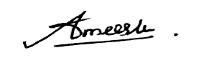 | 13.01.2026
2. | K.M.N.I Abeyrathne |  | 13.01.2026
3. | M.P.S. Magamage |  | 13.01.2026
4. | P.N.C.Fernando |  | 13.01.2026

- Contact details of Co-responding author:
Full Name: | Piramanage Ameesha Madhurangi Pathmasiri
Official Address: | Department of Livestock Production, Faculty of Agricultural Sciences, Sabaragamuwa University of Sri Lanka, P.O. Box 70140, Belihuloya, Sri Lanka.
Email Address: | ameeshapathmasiri@gmail.com
T. Number (Mobile): | 0712199426
Signature: | 

All authors must sign the consent form for the consideration of the research work to ICDA
2026

ICDA-2026 Secretariat, Faculty of Agriculture, University of Jaffna, Ariviyal Nagar, Kilinochchi 44000, Sri Lanka.
TP+94(0) 77 825 2821: /+94(0) 77 326 4666/+94(0) 77 638 1736/+94(0) 77 941 8078
Fax: +94 (0) 212060175 / Email: icda@univ.jfn.ac.lk / Web: https://www.juice.jfn.ac.lk/icda/

