Investigating the Causes of Underperformance in State-owned Farms – A Case Study in “X” Farm, Sri Lanka.

1. Introduction
Agriculture plays a vital role in Sri Lanka’s economy by contributing to food security, rural employment, and income generation (F, 2017). Within this sector, government-managed livestock farms are expected to enhance domestic production, support rural livelihoods, and reduce dependence on imported animal products (Hitihamu, 2025).
Despite significant public investment, many government livestock farms have consistently demonstrated underperformance in terms of productivity, profitability, and operational efficiency. Weak management practices, inefficient resource utilisation, outdated technology, and low labour motivation have constrained their ability to achieve national production targets. These inefficiencies raise concerns regarding the effective use of public resources and the long-term sustainability of state-owned agricultural enterprises (F, 2017).
“X” Farm, a government-managed livestock farm located in Sri Lanka’s dry zone, reflects these challenges. Although the farm possesses adequate land, livestock, infrastructure, and human resources, its production outcomes remain below expected standards. Persistent issues, including rising feed costs, inadequate supervision, limited training opportunities, and low worker motivation, have negatively impacted overall farm performance (State-owned Farm Annual Reports).
Understanding the underlying causes of underperformance in government farms is essential for improving efficiency, strengthening management systems, and ensuring sustainable agricultural development. However, existing studies largely emphasise technical productivity, while managerial and institutional inefficiencies within state-owned farms receive limited attention.
Therefore, this study aims to investigate the key internal factors contributing to underperformance in “X” Farm, with particular emphasis on management practices, labour motivation, resource utilisation, and cost structures. The findings are expected to provide practical recommendations to enhance the performance and sustainability of government-managed livestock farms in Sri Lanka.

2. Materials and Methods
This study adopted a descriptive and analytical case study design to examine the causes of underperformance in “X” Farm. A mixed-method approach was employed, combining both quantitative and qualitative data to obtain a comprehensive understanding of operational and managerial issues.
“X” Farm is a government-owned livestock farm located in the dry zone of Sri Lanka. The farm is engaged in dairy and egg production and operates under challenging climatic conditions characterized by low rainfall and periodic feed and water shortages.
Data Collection
Both primary and secondary data were used.
Primary data were collected through:
Semi-structured interviews with the farm manager and staff members, Structured questionnaires administered to labourers to assess motivation, training access, and job satisfaction and Direct observation of farm operations, labour performance, animal health, feeding practices, and infrastructure conditions
Secondary data included:
Internal farm production and financial records (2019–2024), Published annual reports, Publications from the Department of Animal Production and Health, Relevant academic journals and policy documents
Sample
The study covered all categories of employees at the farm, including one farm manager, supervisory staff, administrative staff, and field labourers, totaling 45 respondents.
Data Analysis
Quantitative data were analysed using SPSS software, employing descriptive statistics, correlation analysis, and regression models to identify relationships between costs, production, and profitability. Qualitative data from interviews and observations were analysed thematically to support and interpret quantitative findings.
Ethical Considerations
Participation was voluntary, informed consent was obtained, and confidentiality of respondents was strictly maintained. The data were used solely for academic purposes.

3. Results, Discussion and Conclusion
Part A – Farm Production and Financial Data Analysis (2019-2024)
Descriptive Statistics
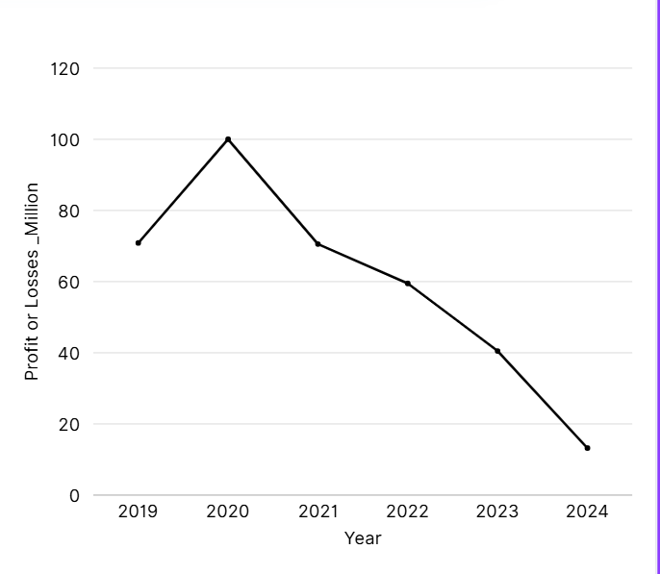
Fluctuation of year with profit

Part B – Staff Perception and Motivation Analysis
Descriptive frequencies (what employees said)
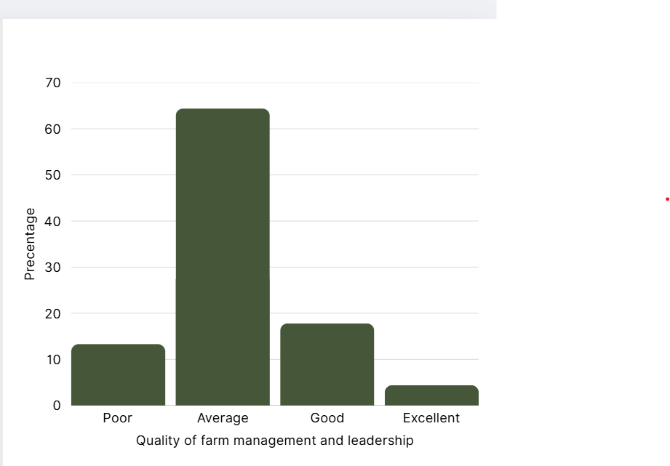
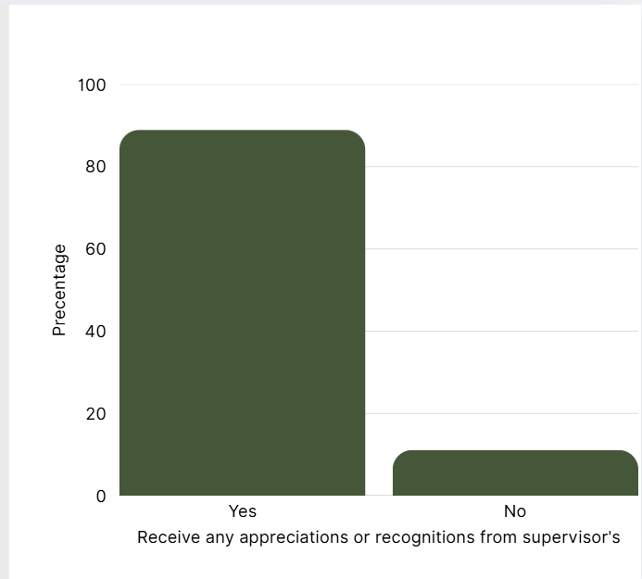

Chi - Square

Purpose: | Examine the association between training and skill development opportunities, and feelings about the motivation
Chi-Square Value (χ²) | 1.439ª
Degrees of Freedom (df) | 2
Significance (p-value) | .487
Purpose: | Examine the association between the quality of farm management and leadership and the Satisfaction with the current yield.
Chi-Square Value (χ²) | 13.258ª
Degrees of Freedom (df) | 9
Significance (p-value) | .151

The analysis of farm production and financial data revealed that “X” Farm has experienced unstable and often declining profitability over the study period. Feed cost emerged as the dominant operational expense, accounting for the largest share of total costs. Despite increased expenditure on feed, improvements in milk and egg production were marginal, indicating inefficiencies in feed utilization and overall resource management.
Correlation analysis showed a strong negative relationship between feed costs and profit, suggesting that rising input costs were not matched by proportional productivity gains. Regression results further confirmed that feed cost was the most significant factor influencing farm profitability, while labour and maintenance costs had comparatively weaker effects.
Employee survey findings highlighted several internal management-related issues. Most respondents rated management quality as “average” or “poor.” More than two-thirds of workers reported receiving no formal training, and most indicated low or moderate motivation levels. Nearly 90% of respondents stated that they did not receive any form of performance-based rewards or recognition.
Qualitative evidence from interviews reinforced these findings. Workers frequently mentioned lack of appreciation, weak supervision, delayed decision-making, and limited opportunities for skill development. Managers acknowledged challenges related to procurement delays, rising feed prices, and constraints in adopting modern technologies.
Discussion
The findings reveal low productivity and weak management systems at X Farm, characterised by poor management quality, limited training opportunities, and ineffective supervision. More than 70% of employees reported that they had never received formal training or recognition, indicating deficiencies in human resource management and leadership practices. The absence of intermediate leadership roles, with all laborers reporting directly to a single farm manager, further constrains operational efficiency. Additionally, inappropriate workplace behaviors, such as betel chewing during working hours, pose potential risks to milk quality and food safety.
Inefficient resource utilization was also evident, as only a portion of the farm’s 199.6 ha of land is productively used approximately 50 acres for grazing and infrastructure and 30 acres for maize cultivation, while a substantial area remains underutilized. Moreover, an unmaintained circuit bungalow located near the lake represents a missed opportunity for agro-tourism development and supplementary income generation.
Collectively, these inefficiencies contribute to broader macroeconomic vulnerabilities, including reduced domestic milk production leading to increased import expenditure, declining rural incomes that exacerbate poverty and migration, and the misallocation of state subsidies, resulting in reduced fiscal efficiency.
The findings of this study are consistent with previous research on inefficiencies in state-owned agricultural enterprises in Sri Lanka. Weak managerial practices, inadequate labour motivation, and inefficient resource utilization have been widely identified as key contributors to underperformance in public sector farms.
The dominance of feed cost without corresponding productivity improvements indicates poor planning, lack of cost control mechanisms, and limited use of alternative feeding strategies. This aligns with studies highlighting feed management as a critical weakness in government livestock farms.
Human resource management emerged as another major concern. Limited training, absence of incentive systems, and weak performance monitoring reduced employee motivation and productivity. According to motivation theories, such conditions discourage effort and commitment, ultimately lowering operational efficiency.
Furthermore, the limited adoption of modern technologies and data-driven management practices restricted the farm’s ability to optimize production and control costs. These institutional and managerial shortcomings, rather than resource scarcity alone, explain much of the observed underperformance.
Conclusion
This study concludes that the underperformance of “X” Farm is primarily driven by internal managerial and operational inefficiencies rather than a lack of physical resources. High feeding costs, weak cost management, inadequate supervision, low labour motivation, and limited training opportunities are the main factors constraining farm performance.
Improving management systems, strengthening human resource practices, and enhancing resource utilization are essential to improving productivity and sustainability in government-managed farms. Addressing these issues can help ensure more effective use of public investment and improve the contribution of government farms to Sri Lanka’s agricultural sector.

References
State-owned farm annual reports.
Gunasekara, D., Wickramasinghe, R., & Herath, H. (2021). Factors influencing efficiency in Sri Lankan livestock farms. University of Peradeniya.
Factors Affecting Technical Efficiency of Dairy Production in the Dry Zone of Sri Lanka.(Sagarika Hitihamu Uthpala Jayasinghe G.V. Norica Aiome)
Department of Animal Production and Health (DAPH). (2023). Livestock Statistical Bulletin. Sri Lanka.
Zogning, F. (2017). Agency theory: A critical review. European Journal of Business and Management, 9(2), 1–8.

