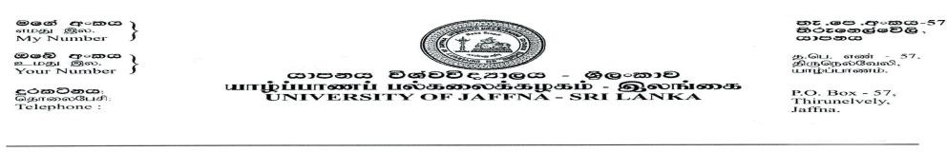
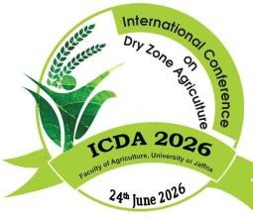

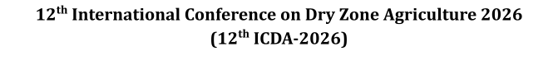


Author(s) Consent form- ICDA 2026

- I undersigned declare and acknowledge that:
  - I have authored the research work entitled
Integration of Predictive Microbiology and Physiochemical Parameters for Shelf-life estimation of different Flavored Drinking Yoghurts.
  - I agreed to submit the above research work to the 12th International Conference on Dry Zone Agriculture (ICDA) 2026 organized by the Faculty of Agriculture, University of Jaffna
  - The abstract submitted for ICDA 2026 reports original research carried out by the authors mentioned and has not been published or submitted for publication elsewhere. Further I understand that the editor’s decision is final on the outcome of the publication.
  - If the manuscript is accepted for an oral presentation, Faculty of agriculture, University of Jaffna has the right to publish in the 12th ICDA proceeding
  - The research remains the intellectual property of the authors, who are entitled to submit it for the publication in other journals or Journal of Dry Zone Agriculture published by Faculty of Agriculture, University of Jaffna

- Preferred sub theme(s) for submission:
1. | Food Science and Nutrition

- Names and signatures of authors in the order they appear in the abstract:
 | Authors Name | 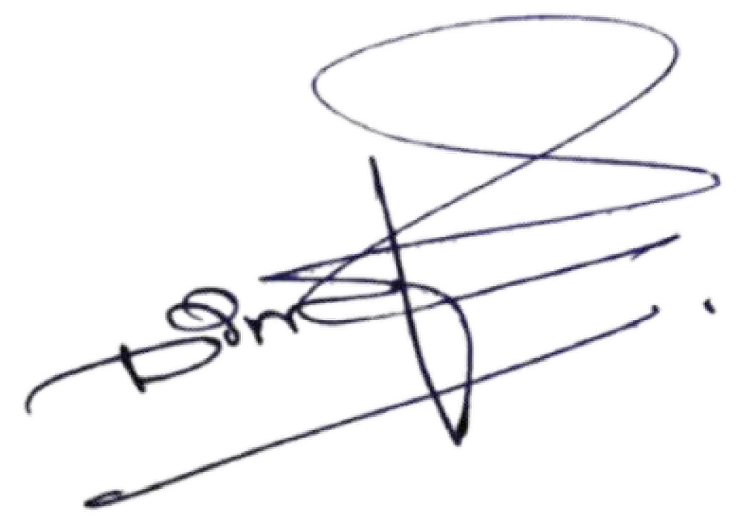  Signature | Date
1. | Sadhurshika Jegatheeswaran |  | 14.01.2026
2. | Rajeetha Jeisunthar | 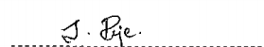 | 14.01.2026
3. | D.C.S. Gunasekara |  | 14.01.2026

- Contact details of Co-responding author:
Full Name: | Rajeetha Jeisunthar
Official Address: | Faculty of Technology, University of Jaffna.
Email Address: | Rajeisantha313@yahoo.com
T. Number (Mobile): | 0778489669
Signature:

Full Name: | D.C.S. Gunasekara
Official Address: | CIC Dairies Pvt Lmt. Dambulla
Email Address: | dimuthu@cicagri.com
T. Number (Mobile): | 0770578640
Signature: | 