Green Synthesis of Iron Nanoparticles Using Made Tea and Refused Tea for Dye Removal in Wastewater

1. Introduction
Iron-based nanoparticles have attracted significant attention in recent years due to their cost-effectiveness, magnetic properties, high surface area, and strong adsorption capacity, making them highly suitable for wastewater treatment applications. Conventional chemical and physical synthesis methods of iron nanoparticles often involve toxic reagents, high energy consumption, and secondary pollution risks. As a result, green synthesis approaches using plant-based materials have emerged as sustainable alternatives.
The tea industry in Sri Lanka, generates a substantial amount of by-products during processing. Refused tea, which is rejected during quality grading, accounts for approximately 4–6% of total tea production and is generally discarded (Rupasingha and Nandasena, 2006). At the same time, industrial wastewater contaminated with synthetic dyes such as methyl orange remains a serious environmental concern because of its toxicity, persistence, and resistance to conventional treatment methods. Although iron nanoparticles are effective in dye removal, traditional synthesis routes are costly and environmentally hazardous. Tea leaves are rich in polyphenols, flavonoids, and other bioactive compounds that can act as natural reducing and stabilizing agents in nanoparticle synthesis (Rodríguez-Rasero et al., 2024). Therefore, use of polyphenols found in various types of green, black and refused tea provides an excellent avenue for green synthesis of nano particles. This is in turn offer a sustainable, low-cost, and environmentally friendly approach that simultaneously addresses tea waste valorization and wastewater treatment. Accordingly, the current study explores the green synthesis of iron nanoparticles using aqueous extracts of made tea and refused tea from black and green tea varieties and evaluates their effectiveness in removing methyl orange dye from wastewater.

2. Materials and Method

2.1 Materials

2.1.1. Materials
- CTC dust 1 black tea
- CTC refused tea
- Gunpowder 1 green tea
- Green tea refused tea

2.1.2. Reagents
- Ferric chloride (FeCl₃)
- Methyl orange
- Hydrochloric acid (HCl)
- Sodium hydroxide (NaOH)
- Double distilled water

2.1.3. Equipment and Apparatus
- X-ray Diffraction (XRD)
- Scanning Electron Microscopy (SEM)
- Fourier Transform Infrared Spectroscopy (FTIR) (Model Alpha Platinum A, USA)
- UV – Visible Spectroscopy (Model Shimadzu UV-1900i, Japan)
- Analytical balance (± 0.001 g) (Model Shimadzu ATX224R, Japan)
- Water bath (Model YIHDER BH – 230D, Taiwan)
- Oven (Model Gemmyco YCO - No 1, Spain)
- Mixer grinder (Model Panasonic MX-AC555, India)
- pH meter (Model HI98190, Romania)
- Refrigerator (Model Thermo scientific ES series, North Carolina)
- Magnetic stir (Model Arex Digital, Italy)
- Centrifugate (Model SORVALL ST16, Germany)
- Sieve (0.500 mm)
- Water activity meter (Model Aqua Lab 4TE, USA)
- Moisture content meter (Model Shimadzu MOC63u, France)

2.1.4. Statistical Software
- Minitab version 17

2.2 Preparation of Tea Extracts
Aqueous extracts (10% w/v, pH ≈ 5.5) were prepared from four tea types: black made tea (CTC Dust 1), black refused tea, green made tea (Gunpowder 1), and green refused tea. The extracts were obtained by heating tea samples in distilled water, followed by filtration and cooling to room temperature.

2.3 Synthesis of Iron Nanoparticles
Iron nanoparticles were synthesized by reacting tea extracts with 0.10 M ferric chloride (FeCl₃) solution in a 1:2 volume ratio under mechanical stirring at room temperature for 2 hours. The formed nanoparticles were separated by centrifugation, washed three times with deionized water, and oven-dried at 60 °C for 24 hours.
Nanoparticle Yield = Final weight of nanoparticles with container - Initial weight of container

2.4 Characterization
The synthesized nanoparticles were characterized using Fourier Transform Infrared Spectroscopy (FTIR) to identify functional groups, UV–Visible Spectroscopy to confirm nanoparticle formation, X-ray Diffraction (XRD) to determine structural properties, and Scanning Electron Microscopy (SEM) to observe morphology and particle size.

2.5 Dye Removal in waste water
Methyl orange dye removal experiments were conducted using an initial dye concentration of 50 mg L⁻¹ at pH 6.5, with a contact time of 120 minutes, agitation speed of 150 rpm, and temperature of 25 °C. Nanoparticle dosages of 1.0 and 2.0 g L⁻¹ were tested. Control experiments using tea extracts or FeCl₃ alone were also conducted.
$$Dye Removal \left(\%\right)=\frac{C^{1}- C^{0}}{C^{1}} ×100$$
- C¹ – Initial Concentration
- C⁰ – Final Concentration

3. Results, Discussion, Conclusion and Recommendations

3.1 Characterization of Iron Nanoparticles
As indicated in figure 1 FTIR spectra revealed the presence of polyphenolic functional groups such as O–H, C=O, and C–O, confirming their role in iron ion reduction and nanoparticle stabilization. Fe–O stretching vibrations observed at 564–576 cm⁻¹ indicated the formation of iron-based nanoparticles (Gautam et al., 2018; Abdullah et al., 2020). As indicated in figure 2 UV–Visible spectroscopy showed strong ultraviolet absorption with a characteristic edge around 390 nm, confirming nanoparticle formation. According to figure 3 XRD analysis revealed predominantly amorphous or nanocrystalline structures with a weak, broad peak at 2θ ≈ 44.7–45.1°, indexed to the (110) plane of body-centered cubic α-Fe. As indicated in figure 4 SEM images showed irregular, quasi-spherical nanoparticles with sizes ranging from 30 to 80 nm, exhibiting agglomeration due to magnetic interactions (Gautam et al., 2018).
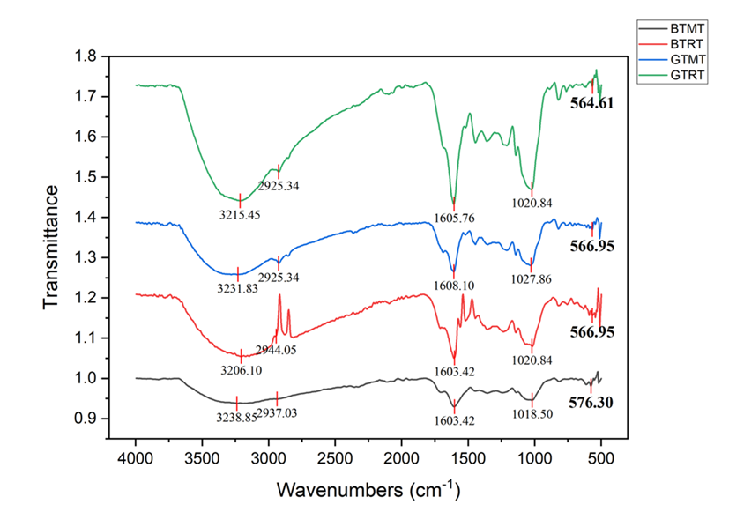

Figure 1: FTIR spectra of four different tea extracts; BTMT – Black Tea Made Tea, BTRT – Black Tea Refused Tea, GTMT – Green Tea Made Tea, GTRT – Green Tea Refused Tea
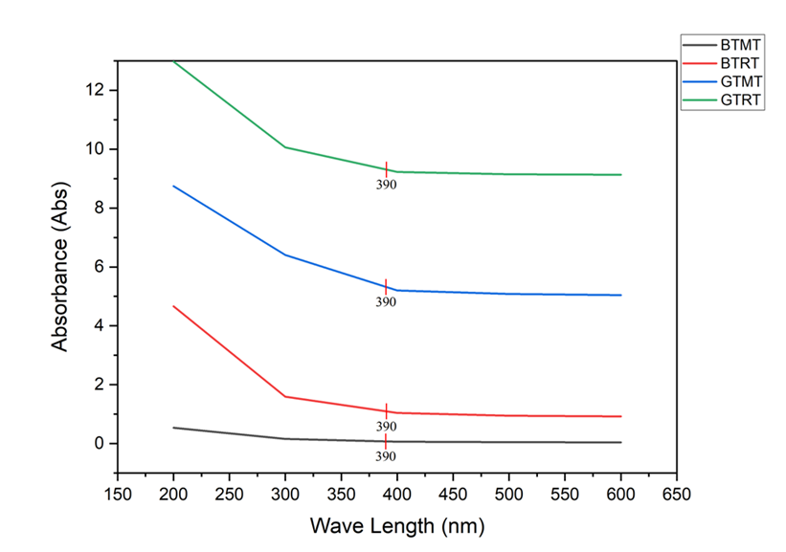

Figure 2: UV–visible spectrum of the absorbance of Fe-NPs synthesized by four different tea extracts; BTMT – Black Tea Made Tea, BTRT – Black Tea Refused Tea, GTMT – Green Tea Made Tea, GTRT – Green Tea Refused Tea
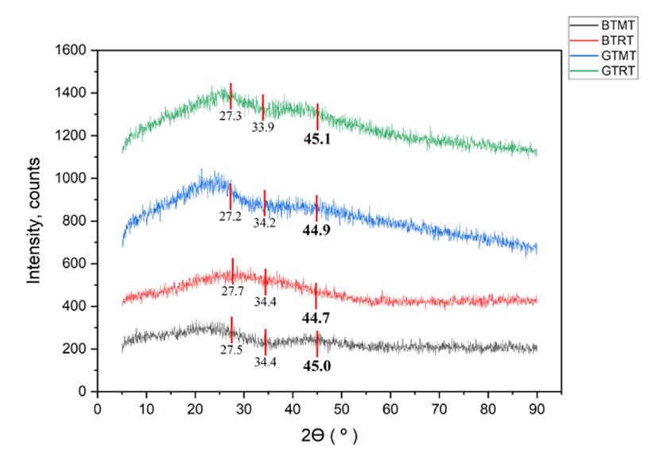

Figure 3: XRD pattern of four different tea extracts; BTMT – Black Tea Made Tea, BTRT – Black Tea Refused Tea, GTMT – Green Tea Made Tea, GTRT – Green Tea Refused Tea
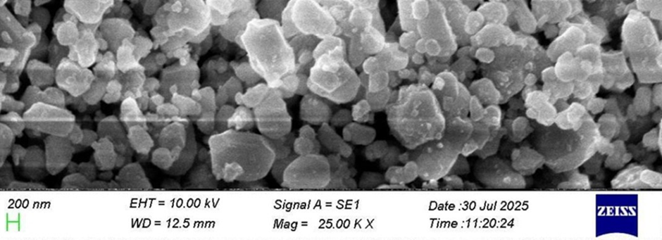
Figure 4: Scanning electron microscopy (SEM) image of Fe-NPs synthesized by GTRT tea extract

3.2 Synthesis Yield
The synthesis yield varied depending on tea type. Green made tea produced the highest yield (65.5 ± 1.5%), followed by green refused tea (65.6 ± 3.1%), black made tea (52.9± 2.5%), and black refused tea (39.2 ± 2.9%). These differences highlight the influence of tea type and phytochemical composition on nanoparticle formation.
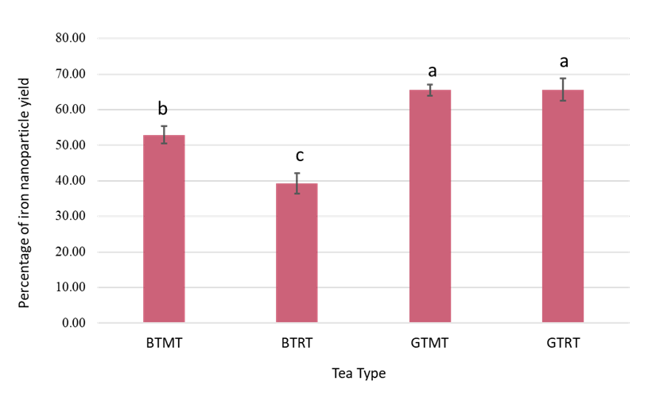

Figure 5: Mean percentage of iron nanoparticle yield by Tea Types in 1:2 volume ratio of Tea extract and FeCl₃

The higher yields observed in green tea made tea and green tea refused tea can be attributed to the higher concentration of polyphenolic compounds, catechins, and flavonoids naturally present in green tea, which are known to act as electron donors during the reduction of Fe³⁺ ions to Fe⁰ nanoparticles (Ahmad et al., 2012; Singh et al., 2018). In contrast, black tea undergoes extensive oxidation during fermentation, which reduces the availability of catechins and other phenolic compounds, thereby limiting its nanoparticle synthesis efficiency (Obanda & Owuor, 1997).

3.3 Methyl Orange Dye Removal Efficiency
Iron nanoparticles synthesized from black made tea showed the highest dye removal efficiency (80.5 ± 1.8%) with an adsorption capacity of 40.3 mg g⁻¹. This was followed by green made tea (75.3 ± 0.9%; 37.7 mg g⁻¹), green refused tea (70.6 ± 1.3%; 35.3 mg g⁻¹), and black refused tea (63.8 ± 0.8%; 31.9 mg g⁻¹). Increasing nanoparticle dosage from 1.0 to 2.0 g L⁻¹ improved dye removal efficiency to 85.7%. Control experiments showed negligible dye removal (<5%), confirming the role of synthesized nanoparticles.
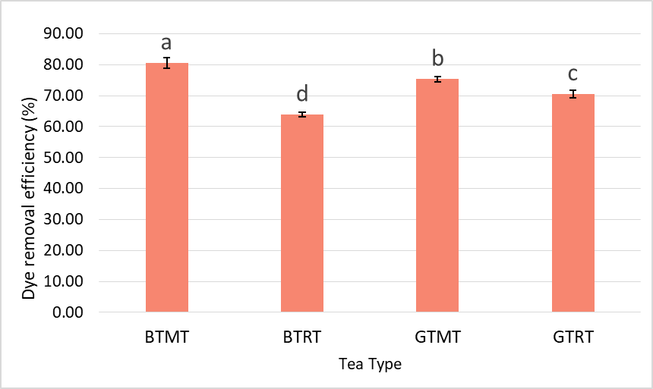
The discrepancy between synthesis yield and dye removal efficiency indicates that surface chemistry and functional group availability play a more critical role than nanoparticle quantity alone. The dye removal mechanism is primarily attributed to adsorption, supported by electrostatic interactions and surface complexation (Ghanim, Al-Kindi and Hassan, 2020; Rauf et al., 2025).

Figure 6: Mean Dye Removal Efficiency by Tea Types
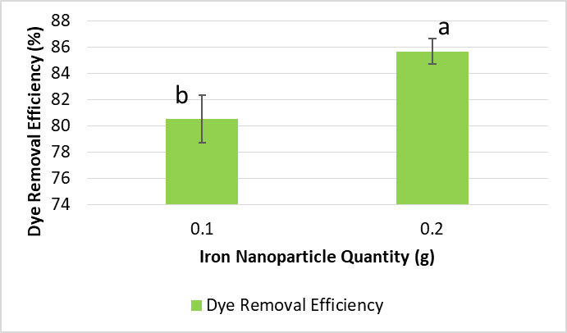

Figure 7: Mean dye removal efficiency by various iron nanoparticle concentrations

3.4 Conclusion
This study successfully demonstrates the green synthesis of iron nanoparticles using made tea and refused tea extracts from black and green tea varieties. Tea-derived bioactive compounds effectively act as natural reducing and stabilizing agents, producing iron-based nanoparticles with promising dye removal capabilities. Although green made tea yielded the highest nanoparticle production, iron nanoparticles synthesized from black made tea exhibited superior methyl orange removal efficiency. The findings highlight the potential of tea waste valorization as a sustainable approach for nanoparticle synthesis and wastewater treatment, contributing to environmentally friendly solutions in green nanotechnology and industrial waste management.

4. References
- Abdullah, J.A.A. et al. (2020) “Green synthesis and characterization of iron oxide nanoparticles by pheonix dactylifera leaf extract and evaluation of their antioxidant activity,” Sustainable Chemistry and Pharmacy, 17, p. 100280. Available at: https://doi.org/10.1016/j.scp.2020.100280.
- Gautam, A. et al. (2018) “Green synthesis of iron nanoparticle from extract of waste tea: An application for phenol red removal from aqueous solution,” Environmental Nanotechnology, Monitoring & Management, 10, pp. 377–387. Available at: https://doi.org/10.1016/j.enmm.2018.08.003.
- Ghanim, D., Al-Kindi, G. and Hassan, A. (2020) “Green Synthesis of Iron Nanoparticles Using Black Tea Leaves Extract as Adsorbent for Removing Eriochrome Blue-Black B Dye,” Engineering and Technology Journal, 38(10A), pp. 1558–1569. Available at: https://doi.org/10.30684/etj.v38i10A.1225.
- Rauf, A. et al. (2025) “Green synthesis an eco-friendly route for the synthesis of iron oxide nanoparticles using aqueous extract of Thevetia peruviana and their biological activities,” Scientific Reports, 15(1), p. 18316. Available at: https://doi.org/10.1038/s41598-025-02387-z.
- Rodríguez-Rasero, C. et al. (2024) “Valorizing Tea Waste: Green Synthesis of Iron Nanoparticles for Efficient Dye Removal from Water,” Antioxidants, 13(9), p. 1059. Available at: https://doi.org/10.3390/antiox13091059.

