Extension officers’ perspectives on Agricultural Extension Service delivery- A qualitative inquiry in Dambulla Agrarian Service Center under Dambulla Divisional Secretariat Division, Sri Lanka

Introduction

Agricultural extension services play a crucial role in bridging the gap between agricultural research and farming practice by facilitating knowledge transfer, technology dissemination, and advisory support to farmers (Elias, et al., 2016) (Kassem, et al., 2021). In developing countries such as Sri Lanka, the effectiveness of extension services largely depends on the capacity, motivation, and working conditions of extension officers who operate at the field level (Athukorala, 2017). Understanding extension service delivery from the perspective of officers is therefore essential for identifying institutional strengths, operational challenges, and opportunities for system improvement (Silva, 2020).
In Sri Lanka, agricultural extension services are primarily delivered through the Department of Agriculture (DOA) via a network of Agricultural Instructors (AIs) and Agricultural Research and Production Assistants (ARPAs). These officers are responsible for providing technical advice, conducting training programs, organizing demonstrations, distributing inputs, and supporting farmers in decision-making processes related to crop production (Athukorala, 2017). Although the extension system is well established institutionally, several studies have reported limitations related to staffing shortages, workload pressures, and coordination gaps that affect service efficiency and quality (Silva, 2020) (Kassem, et al., 2021).
Dambulla area is one of Sri Lanka’s major agricultural regions, particularly for paddy cultivation, with a large and diverse farming population. The high demand for extension support in the area places considerable pressure on field-level officers. While farmer satisfaction with extension services has been widely examined in different contexts (Debnath, et al., 2016) (Elias, et al., 2016), relatively fewer studies have focused on extension officers’ own perspectives regarding service delivery constraints, institutional arrangements, and field realities. Such insights are critical for designing realistic and implementable reforms that enhance extension effectiveness (Kassem, et al., 2021).
This study aims to examine the perspectives of extension officers on the structure, effectiveness, and challenges of agricultural extension service delivery in the Dambulla area. By capturing officers’ experiences and views, the study seeks to identify key institutional and operational factors influencing extension performance and to provide evidence-based recommendations for strengthening public agricultural extension services in Sri Lanka (Athukorala, 2017) (Silva, 2020).
Materials and Methods

A qualitative research approach was adopted to gain an in-depth understanding of extension officers’ perspectives on agricultural extension service delivery in Dambulla area. The study was conducted at the Agrarian Service Center, Dambulla, which serves as the primary coordination point for DOA extension activities in the region.
Primary data were collected through semi-structured interviews with fifteen Agricultural Research and Production Assistants (ARPAs) and the Agricultural Instructor (AI) responsible for supervising extension activities in the area. These respondents were purposively selected because of their direct involvement in planning, implementing, and monitoring extension services for paddy farmers. The number of interviews was considered adequate to achieve data saturation, given the relatively homogeneous nature of officers’ roles.
The interview guide covered key themes including the organizational structure of extension services, roles and responsibilities of officers, methods of service delivery, interaction with farmers, resource availability, communication mechanisms, and challenges faced in field-level operations. Interviews were conducted in a conversational manner to encourage open and detailed responses.
Collected data were transcribed and analyzed using thematic analysis following the six-phase approach proposed by Braun and Clarke (2006). An inductive coding process was applied to identify recurring patterns and themes related to extension service delivery. The analysis focused on institutional arrangements, operational constraints, behavioral factors, and officers’ perceived effectiveness of extension interventions. To enhance validity and credibility, themes were reviewed and refined through repeated comparison across respondents to ensure internal consistency and coherence of findings.

Results

Main Theme | Sub-theme | Codes | Sample Utterances
Institutional Structure of Extension Services | Formal organizational framework | Defined roles, hierarchical reporting, DOA guidelines | “Our duties are clearly defined under the DOA, and we work according to official procedures and reporting lines.”
Institutional Structure of Extension Services | Coordination mechanisms | AI–ARPA coordination, farmer organizations, planned programs | “We coordinate training and demonstrations through farmer societies and follow instructions from the AI.”
Operational Constraints in Service Delivery | Human resource shortages | Staff shortage, high farmer–officer ratio, multiple GN divisions | “One officer has to cover two or three GN divisions, so regular field visits are not possible.”
Operational Constraints in Service Delivery | Time limitations | Limited follow-up, delayed responses, workload pressure | “Most of our time goes into meetings and paperwork, leaving little time for field monitoring.”
Communication and Accessibility Challenges | Limited farmer contact | Infrequent visits, indirect communication | “We mostly communicate during meetings, visiting every field is difficult.”
Communication and Accessibility Challenges | Digital and literacy barriers | Low smartphone use, poor network, low digital skills | “Some farmers don’t use smartphones, so WhatsApp messages don’t always reach them.”
Behavioral and Contextual Factors | Resistance to new technologies | Traditional practices, age-related resistance | “Older farmers prefer traditional methods and hesitate to try new recommendations.”
Behavioral and Contextual Factors | Dependency mindset | Expectation of subsidies, low self-initiative | “Some farmers depend on government support rather than adopting new practices.”
Resource and Infrastructure Limitations | Physical resource constraints | Lack of transport, demo materials | “Without proper transport, visiting distant fields becomes very difficult.”
Resource and Infrastructure Limitations | Administrative burden | Documentation, reporting duties | “Administrative work takes a lot of time that could be used for fieldwork.”
Perceived Effectiveness of Extension Services | Positive officer commitment | Professional dedication, service motivation | “Even with limitations, we try our best to support farmers.”
Perceived Effectiveness of Extension Services | Differential farmer outcomes | Training participation, regular contact | “Farmers who attend training and keep in touch usually perform better.”
Table 1: Thematic analysis table

The findings indicate that extension officers perceive the agricultural extension service delivery system in Dambulla area as organizationally well-structured, with clearly defined roles and responsibilities under the Department of Agriculture (DOA). Agricultural Instructors (AIs) and Agricultural Research and Production Assistants (ARPAs) operate within a formal administrative framework that facilitates coordination, reporting, and implementation of extension activities such as training programs, demonstrations, advisory services, and input distribution.
Despite this structured system, officers consistently reported several operational constraints that limit service effectiveness. The most prominent issue was the shortage of extension staff, resulting in high farmer-to-officer ratios. Many ARPAs are required to cover multiple Grama Niladhari divisions, which significantly reduces the time available for regular field visits and individualized farmer support.
Officers also reported limited time for follow-up activities, making it difficult to monitor farmer fields continuously and respond promptly to emerging issues such as pest outbreaks, irrigation problems, and input shortages. Communication gaps between officers and farmers were frequently mentioned, particularly due to limited digital access and varying levels of technological literacy among rural farmers.
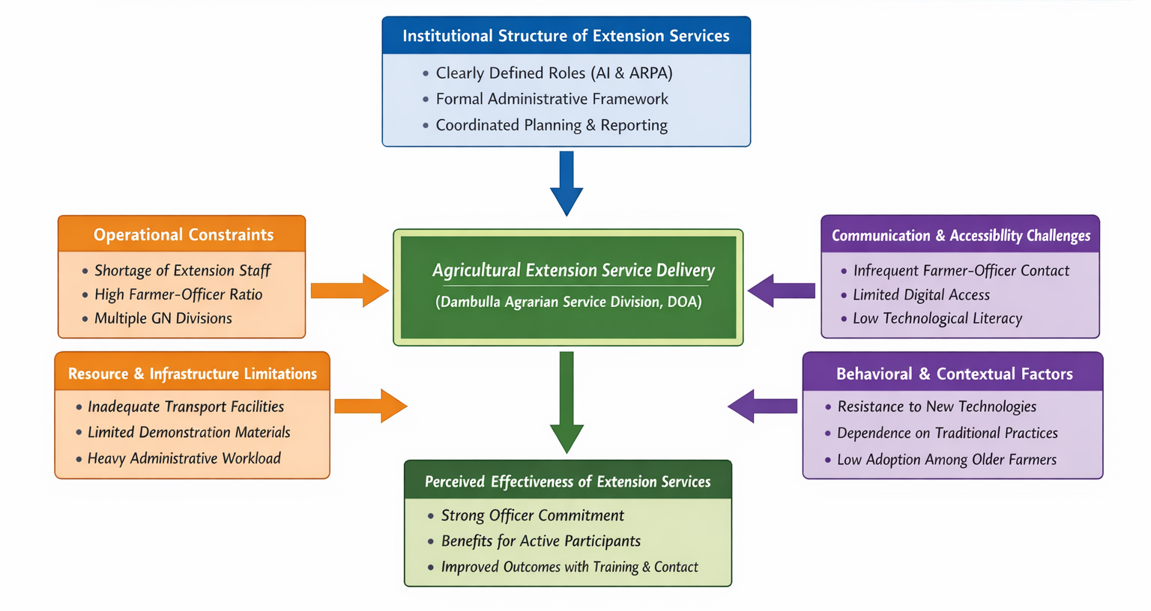
In addition, officers identified behavioral and contextual challenges, including resistance to new technologies among older farmers and dependence on traditional farming practices. Resource constraints such as inadequate transport facilities, limited demonstration materials, and heavy administrative workloads further restricted officers’ capacity to focus on field-level extension activities. Nevertheless, officers emphasized their commitment to service delivery and noted that farmers who actively participate in training programs and maintain regular contact benefit more from extension interventions.
Figure 1: Thematic map of Extension officers’ perspectives on Agricultural Extension Service delivery in Dambulla Agrarian Service

Discussion

The results suggest that while the DOA’s extension system in Dambulla is institutionally sound, its functional effectiveness is constrained by operational and human resource limitations. The high workload and staff shortages reported by officers mirror findings from previous studies in Sri Lanka, which highlight that limited extension personnel reduce contact frequency and service quality (Silva, 2020).
The difficulty in conducting regular field visits and follow-up activities has important implications for extension effectiveness. (Athukorala, 2017) demonstrated that continuous monitoring and advisory support significantly improve agricultural performance, indicating that limited follow-up weakens the potential impact of extension services. The officers’ concerns regarding communication gaps further reinforce the importance of reliable and inclusive communication systems, as emphasized by (Kassem, et al., 2021).
Behavioral resistance among farmers, particularly older farmers, aligns with findings by (Elias, et al., 2016), who noted that attitudes toward innovation strongly influence extension outcomes. Officers’ observations that actively engaged farmers benefit more from extension services support the argument that extension effectiveness depends on both institutional capacity and farmer participation.

Overall, the findings highlight a mismatch between the expected role of extension officers and the practical constraints under which they operate, suggesting that system-level improvements are required to translate institutional strength into effective field-level impact.

Conclusion
This study concludes that extension officers in Dambulla area operate within a well-established organizational framework, but the effectiveness of agricultural extension service delivery is limited by staff shortages, high workloads, communication barriers, and resource constraints. Although officers demonstrate strong professional commitment, these limitations restrict regular field interaction, timely follow-up, and responsiveness to farmers’ needs. The findings emphasize that improving agricultural extension effectiveness requires addressing structural and operational challenges faced by extension officers. Strengthening human resource capacity and improving working conditions are essential for enhancing service delivery and achieving intended extension outcomes.

Recommendations
To improve agricultural extension service delivery in Dambulla area, it is recommended to strengthen staffing capacity by recruiting additional extension personnel to reduce workload pressures and improve farmer-to-officer ratios. Enhancing field-level interaction through improved transport facilities and reduced administrative burdens would allow officers to conduct regular visits and follow-up activities. Improving communication mechanisms, including appropriate digital tools and farmer-friendly information channels, can help bridge information gaps. In addition, promoting farmer participation and awareness programs may help address resistance to new technologies and improve the overall effectiveness of extension interventions.

References

Athukorala, W., 2017. Identifying the role of agricultural extension services in improving technical efficiency in the paddy farming sector in Sri Lanka. Sri Lanka Journal of Economic Research..
Debnath, A., Saravanan, R. & Datta, J., 2016. Farmers’ Satisfaction with the Public Agricultural Extension Services in Tripura State of North-East India. International journal of social sciences.
Elias, A., Nohmi, Yasunobu & Ishida, 2016. Farmers’ Satisfaction with Agricultural Extension Service and Its Influencing Factors: A Case Study in North West Ethiopia. Journal of Agricultural Science and Technology.
Kassem, Alhafi, A. B., Muddassir, M. & Herab, A., 2021. Factors influencing farmers' satisfaction with the quality of agricultural extension services.. https://doi.org/10.1016/j.evalprogplan.2021.101912.
Silva, K. N. N., 2020. The Roles of Absorptive Capacity, Technology Adoption, and Extension, Services in a Local Agricultural Innovation, System in Sri Lanka. s.l.: Institutionelles Repositorium der Leibniz Universität Hannover.

