Eusocial structure of Macrotermes and competitive ability of Mycopathogens targeting Termitomyces and the Termites using different eco-friendly formulatons
S.Kugatharshini*, V.Jegathambigai, S.Sritharan and G.Mikunthan
Department of Agricultural Biology, Faculty of Agriculture, University of Jaffna, Ariviyal Nagar, Kilinochchi, Sri Lanka.
*Corresponding Author: S.Kugatharshini- ttharsi66@gmail.com
Abstract
The mutualistic relationship between Macrotermes termites and their symbiotic fungus Termitomyces, with emphasis on mound structure, functional organization, and the potential use of fungal antagonists as eco-friendly biocontrol agents for sustainable termite management. Field observations showed that Macrotermes mounds were dome-shaped with multiple ventilation holes measuring 3–6 cm in diameter, an average height of 120 cm, and a width of 190 cm. Internal examination revealed well-organized chambers containing fungus combs with a mean fresh weight of 230.47 ± 92 g, a perimeter of 37.5 ± 5 cm, and a volume of 1793.1 ± 926 cm³, indicating advanced eusocial organization and efficient resource allocation. The isolated Termitomyces species displayed white, cottony mycelial growth with basidiomycete characteristics, including clamp connections observed microscopically. Dual culture assays demonstrated strong antagonistic activity of T. viride against Termitomyces, achieving 83.33% inhibition of radial growth after 14 days. An eco-friendly substrate formulation containing tamarind seed and fenugreek seed supported maximum mycelial growth and sporulation (6.23 ± 0.3 × 10⁶ spores g⁻¹) at an optimal pH range of 5.5–6.5. T. viride colonized sterilized termite combs more effectively than wild combs, suggesting that native microbial flora restricted colonization. Laboratory bioassays revealed a significant effect (p < 0.05) of entomopathogenic fungi on termite mortality, with Paecilomyces cerevisiae causing the highest mortality (85%), followed by Metarhizium anisopliae (75%) and Beauveria bassiana (49.3%). Overall, the findings support the use of fungal-based biocontrol agents in environmentally sustainable Integrated Pest Management strategies.

Key words: Entomopathogenic fungi, Macrotermes, Termites, Termitomyces, Trichoderma viride

Introduction
Among the most ecologically significant soil insects in tropical ecosystems are termites of the genus Macrotermes. These termites exhibit a highly evolved eusocial organization composed of reproductive, worker, and soldier castes that coordinate complex behaviors such as nest construction, foraging, and fungal cultivation (Ocko et al., 2019). One of the most distinctive features of Macrotermes is the construction of massive earthen mounds, often exceeding two meters in height. These mounds function as biogenic structures that regulate temperature, humidity, and gas exchange, thereby creating optimal conditions for the growth of their obligate symbiotic fungus, Termitomyces. Cultivated within specialized internal combs, Termitomyces plays a crucial role in degrading lignocellulosic plant material and providing essential nutrients required for colony survival and growth (Zachariah et al., 2020).
Despite their ecological importance in soil aeration, nutrient cycling, and fertility enhancement, Macrotermes species are also recognized as major agricultural and structural pests. They attack root systems and wooden structures of economically important crops such as tea, maize, and sugarcane, resulting in substantial yield losses and economic damage worldwide (Rana et al., 2021). Consequently, sustainable termite management has become a critical concern, particularly in tropical regions where prolonged reliance on chemical control has caused soil contamination, non-target organism toxicity, and the development of pest resistance (Awasthi et al., 2024).
Recent research has increasingly focused on environmentally benign biological control strategies that exploit antagonistic interactions within the termite–fungus symbiotic system. Mycopathogenic fungi such as Trichoderma viride, known for their biocontrol mechanisms including nutrient competition, enzyme secretion, and antibiosis, have demonstrated antagonistic effects against Termitomyces. Dual culture studies have shown that T. viride can significantly inhibit the radial growth of Termitomyces, potentially disrupting the termite–fungus mutualism (Xiong et al., 2019). In addition, entomopathogenic fungi such as Beauveria bassiana, Metarhizium anisopliae, and Paecilomyces cerevisiae have been reported to infect termite workers by penetrating the cuticle and proliferating within the host, ultimately causing mortality (Subekti et al., 2024).
Therefore, this study aims to investigate the eusocial organization of Macrotermes and evaluate the biopotential of fungal antagonists targeting both termites and Termitomyces. Through mound and comb morphology assessment, dual culture assays, spore ball production, and bioassays with entomopathogenic fungi, the research seeks to develop sustainable alternatives to chemical pesticides for effective termite management.
Materials and Methodology
The study was conducted to investigate the mound architecture, fungal symbiosis, and biocontrol potential of fungal antagonists associated with Macrotermes termites. Termite mounds were identified between Killinochchi and Jaffna, Sri Lanka, and a representative mound located at Ambal Nagar, Killinochchi District, was selected for detailed investigation. External mound morphology, including height, basal and intermediate diameters, and surface openings, was measured using standard measuring tools. The position and diameter of external openings were recorded to assess ventilation and foraging structures.
The mound was dissected vertically using a hand saw to examine internal architecture. Layer-wise observations were made on tunnel networks and fungus comb chambers. Fungus combs were collected carefully, transported to the laboratory, and measured for fresh weight, height, width, and perimeter. Termites at different developmental stages were collected and morphologically examined under a stereo microscope.
Termitomyces was isolated from fungal nodules and comb material using surface sterilization and culturing on Potato Dextrose Agar (PDA). Pure cultures were obtained through repeated subculturing and identified morphologically using the hanging drop technique. A laboratory-maintained culture of Trichoderma viride was used as an antagonist. Dual culture assays were performed on PDA to evaluate antagonistic interactions, and percent inhibition of radial growth (PIRG) of Termitomyces was calculated at different intervals.
For spore ball production, locally available organic substrates were prepared, shaped into balls, sterilized, and inoculated with T. viride spore suspensions. Substrate pH was determined prior to inoculation. Growth and sporulation of T. viride on substrate balls were evaluated by spore counting using a haemocytometer. The ability of T. viride to colonize termite combs was assessed under both natural (unsterilized) and sterilized conditions using different spore concentrations.
Entomopathogenic fungi (Beauveria bassiana, Metarhizium anisopliae, and Paecilomyces cerevisiae) were applied to termite workers under laboratory conditions to evaluate mortality. Treated termites were maintained in high-humidity chambers, and mortality was recorded on the third day. All experiments were conducted in a completely randomized design, and data were analyzed statistically using SAS software with Duncan’s Multiple Range Test at a 95% confidence level.
Results and Discussion
Field surveys conducted in the Kilinochchi and Jaffna districts of Northern Sri Lanka revealed the presence of fungus-growing termites belonging mainly to the genera Macrotermes and Odontotermes. Distinct morphological differences were observed between the mound types. Macrotermes mounds were large, dome-shaped, compact, and well-ventilated, indicating long-term colony establishment and high worker activity, whereas Odontotermes mounds were smaller, irregular, and loosely compacted with numerous surface openings. These differences reflect species-specific adaptive strategies under arid-zone conditions.
Detailed examination of Macrotermes mounds showed a complex external and internal architecture. Mound height ranged from 115–125 cm with basal diameters of 180–200 cm. External ventilation holes (2–6 cm diameter) were distributed across the mound surface, facilitating gas exchange. Internal observations revealed well-defined layers with centrally located fungal comb chambers. Most combs were positioned in the mid-to-lower regions of the mound, connected by fine tunnels forming a continuous ventilation network. This architecture supports stable microclimatic conditions essential for termite survival and Termitomyces growth, functioning as a natural “bioreactor.”
Morphometric analysis of 40 fungal combs showed considerable variability in size and weight, reflecting different developmental stages. Average comb dimensions were 16.25 ± 3.1 cm in length and 12.17 ± 2.6 cm in width, with a mean fresh weight of 230.47 ± 92 g. Larger and heavier combs were concentrated in the mound center, suggesting progressive comb development through continuous remodeling by worker termites.
Pure cultures of Termitomyces were successfully isolated from fungal nodules and 3-day-old combs, while fresh combs showed heavy microbial contamination. Dual culture assays demonstrated strong antagonism by Trichoderma viride, which significantly inhibited the radial growth of Termitomyces, reaching 83.33% inhibition after 14 days. Substrate trials identified tamarind seed + fenugreek seed as the most suitable formulation for T. viride sporulation. Entomopathogenic fungi caused significant termite mortality, with Paecilomyces showing the highest effectiveness. Overall, the findings highlight the strong potential of fungal antagonists as eco-friendly biocontrol agents for sustainable termite management.

Dual culture of Termitomyces and Trichoderma viride
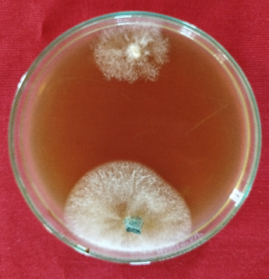 | 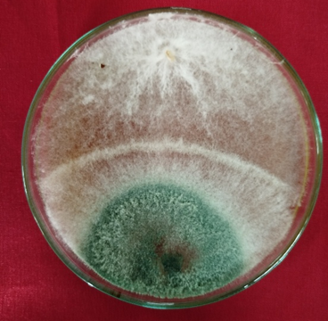
Plate 1(a) | Plate 1(b)
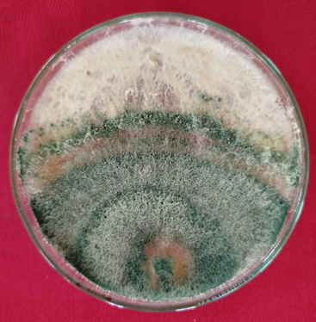 | 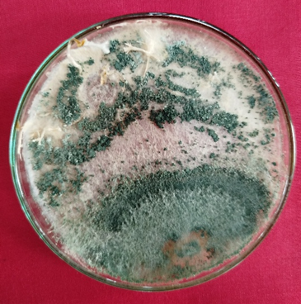
Plate 1(c) | Plate 1(d)

Plate1: Dual culture assay of Termitomyces and T. viride on PDA medium. (a): 3 days of inoculation, (b): 5 days of inoculation, (c): 7 days of inoculation, (d): 14 days of inoculation.

Percent inhibition of radial growth (PIRG) of Termitomyces
Table 1: Percent inhibition of radial growth (PIRG) of Termitomyces

Growth and colonization pattern of T. viride on different substrate balls
Figure1: Combined graph showing substrate pH (line) and spore count of T. viride (bars) after 14 days of incubation.
Mortality of termites treated with different Entomopathogenic Fungi(EPF)

Figure 2: Mortality % of termites using different EPF after 3rd day of inoculation.

Conclusion
The present study provides a comprehensive understanding of the eusocial organization and mound architecture of Macrotermes colonies, highlighting their dome-shaped mounds, ventilation systems, and vertically arranged fungal comb chambers that create optimal conditions for the symbiotic fungus Termitomyces. Morphometric analysis revealed considerable variability in fungal comb size and distribution, reflecting adaptive resource allocation by worker termites. Dual culture assays demonstrated strong antagonistic activity of Trichoderma viride against Termitomyces, with a maximum Percent Inhibition of Radial Growth of 83.33% after 14 days, mainly through rapid mycelial overgrowth and nutrient competition. Substrate composition and pH significantly influenced fungal growth and sporulation, with the tamarind seed and fenugreek seed combination supporting the highest spore production, while extreme pH substrates limited development. Colonization of T. viride was greater in sterilized combs, indicating inhibition by native microbial communities. Laboratory bioassays showed that Paecilomyces cerevisiae caused the highest termite worker mortality, followed by Metarhizium anisopliae, emphasizing the potential of eco-friendly fungal formulations for sustainable termite management.

Selected References
- Egan, B., Nethavhani, Z., and van Asch, B. (2021). Overview of the genetic diversity of african macrotermes (Termitidae: Macrotermitinae) and implications for taxonomy, ecology and food science. Insects, 12(6). https://doi.org/10.3390/insects12060518
- Lewis, V. R. (2016). Alternative control strategies for termites. https://www.researchgate.net/publication/285719450
- Manzoor, F., & Mir, N. (2010). Survey of Termite Infested Houses, Indigenous Building Materials and Construction Techniques in Pakistan. In Article in Pakistan Journal of Zoology (Vol. 42, Issue 6). https://www.researchgate.net/publication/259562714
- Mathew, G. M., Ju, Y. M., Lai, C. Y., Mathew, D. C., & Huang, C. C. (2012). Microbial community analysis in the termite gut and fungus comb of Odontotermes formosanus: The implication of Bacillus as mutualists. FEMS Microbiology Ecology, 79(2), 504–517.
- Pervez, A. (2018). Termite Biology and Social Behaviour. In Termites and Sustainable Management (pp. 119–143). Springer International Publishing. https://doi.org/10.1007/978-3-319-72110-1_6
- Van de Peppel, L., De Beer, W., Koné, N., & Aanen, D. (2024). Species and Speciation in the Termite-Cultivated Fungus Termitomyces. Bulletin of the Society of Systematic Biologists, 3(2). https://doi.org/10.18061/bssb.v3i2.9345

- Zachariah, N., Singh, S., Murthy, T. G., & Borges, R. M. (2020). Bi-layered architecture facilitates high strength and ventilation in nest mounds of fungus-farming termites. Scientific Reports, 10(1). https://doi.org/10.1038/s41598-020-70058-2

