Different Hydrothermal treatments in Paddy parboiling process
Enhance the Formation of Resistance Starch during Milling
Prabhaharan¹ M and Mayoorica¹, P.
Contact person: aenpraba@gmail.com
- Department of Agricultural Engineering, faculty of Agriculture, University of Jaffna.

ABSTRACT
The parboiling process leads to improves rice quality and enhances the physio-chemical properties of grains. Parboiled rice exhibits several advantages over raw rice, such as strengthening kernel integrity by forming resistant starch, increased milling recovery and preventing the loss of nutrients during cooking. Agriculture Department recommended paddy varieties with red pericarp (At 362), red pericarp (Bg 366) and one commercial type with red pericarp (Adakari) were used for investigation in this study. Paddy samples were prepared in different duration and methods of soaking and steaming with controls (Raw rice). Different treatments in parboiling practices were investigated on their milling yield qualities, refers as Head Rice Yield (HR) and resistance starch formation (RS) during cooking. Initially, raw paddy samples were soaked in well water at the intervals of a day, 2 days, 3 days, 4 days, and 5 days with a volume ratio of 1:1.5 and the hot water steaming procedure was practiced for 20 minutes’ duration as Soak Steam (SS), Pressurized Soak Steam (PSS), Un-soaked Steam (USS) in an electric rice cooker with steamer. The parboiled paddy was dried under a conventional oven at 60˚C temperature for 3 hrs., which achieved a suitable moisture level for safe milling. An Hardness test was performed to test the internal strength of the rice kernel after cooking. Textural attributes were analyzed (Texture Analyzer) with a 10mm displacement using a, force-versus-distance compression program. Trigger Force (auto), 0.05 N Cooking of Parboiled rice was performed with water in a volume ratio of 1:1.2, duration of 20 minutes in an electric rice cooker. The Highest head rice yield was counted in the Pressure-soaked steam (PSSP) method with 2 days of soaking duration (48 h). Pressure-soaked steam (PSS) yielding harder resistant starch parboiled rice than other parboiling methods. All other compared parboiling methods gave moderate head rice yield and Hardness value. Pressurized soaked steam process was yield higher hardness value product in all treatment process.
Keywords:, Paddy soaking & steaming, Resistant starch, Head rice yield and Hardness.

Background
Rice (Oryza sativa L.) is one of the world's most important food crops, second only to wheat in terms of annual production for human consumption. It is the primary source of nutrition for more than half of the world's population (Miah et al., 2002a). Rice is the most common carbohydrate source in the world's diet. Because of its nutritional and milling dominance, parboiled rice has risen to prominence among rice-based products (Purohit and Rao, 2017)In most developed countries, parboiled rice is consumed by the majority of the population.(Islam, Shimizu and Kimura, 2001). The parboiling method accounts for a significant portion of the global rice processing industry. The requisite hardness is imparted to the grain when paddy is parboiled properly. Before milling, paddy undergoes a hydrothermal treatment known as parboiling. (Purohit and Rao, 2017).
The main goal of parboiling is to gelatinize the starch, which increases the rice's properties and makes dehusking easier(Bello, Abubakar and Lawan, 2015). When cooked to the perfect softness, parboiling results in higher milling recovery, more transparent kernels, and increased swelling (Fofana et al., 2011). Soaking paddy in cold water for 24–48 hours, until the kernels are saturated, is the most common way to complete the three stages of parboiling – soaking, steaming, and drying. To obtain 80 percent gelatinized starch, the soaked paddy is boiled for 1 hour at 100 degrees Celsius. Finally, the sun-dried boiled paddy is dried to a moisture content of 14 percent (Miah et al., 2002b). Different parboiling techniques have traditionally been followed and scientifically developed for the preparation of parboiled rice (Dutta,2014). Analyzing different techniques used for parboiling in terms of their milling yield is essential to increase the efficiency of the system in the rice processing industry, physical properties are playing a key role in consumer preference. One of the methods to acquire all those nutrient is parboiling of rice because parboiled rice which will be rich in all those nutrients. Resistant starch (RS), which is not digested in the small intestine, induces health benefits, as dietary fiber does. Hence, the precise measurement of RS fraction may contribute to identification of functional foods. RS can be measured by using different methodologies. (Alexandre, 2020). Resistant starch (RS) is considered to possess several health benefits. The amylose, RS and their relative changes with Total Starch (TS) in different varieties of rice from Northern Sri Lanka with the different traditional cooking methods were determined. For this study seven each of traditional and improved rice varieties were selected. In order to find the effects of traditional cooking methods, three traditional and improved rice varieties.

Objective of the study:

To investigate the soaking duration and steaming method effect the qualities on milling yield and resistant starch formation by the parboiling process.

MATERIALS AND METHOD

Location
Research was carried at the Department of Agricultural Engineering, Faculty of Agriculture, University of Jaffna. Both raw and parboiled paddy was parboiled, milled and polished, which was carried out at the laboratory of the Lap of Pot-Harvest Technology, Analysis of cooking and extrusion qualities was carried out at the laboratory of the Department of Chemistry, Faculty of Agriculture, University of Jaffna. Both raw and parboiled rice was uncounted in this outcome.

Materials
Samples of popular two Department recommended varieties (Ambalanthota red rice (At 362), Bathalagoda white rice (Bg 366) )and one traditional variety (Adakari rice) were selected. The purity percentage of the three varieties was 99% and the samples have been harvested one month before parboiling.
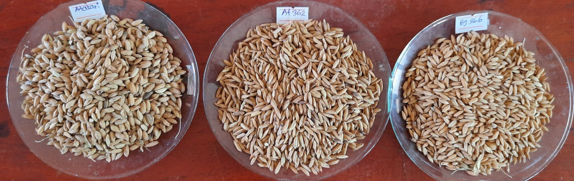
Plate 3.1: Adakari, At 362, Bg 366

Laboratory Parboiling Methods

Experimental setup
Three experiments were planned to check the effect of parboiling methods of selected Sri Lankan rice cultivars on milling yield analysis, analysis of cooking and extrusion qualities. Three popular parboiling methods were selected in this study. Parboiling was done in three important steps. Such as soaking (steeping), steaming and, drying.

Soaked steam parboiling
Paddy varieties, At 362 and Bg 366 and Adakari were soaked in water at ambient temperature (30˚C) for 72 hours (1-3 days soaking). Paddy grains were then steamed till their hulls split off (5.5±0.5%). For steaming rice was put into the rice cooker and water was added 1.5 times higher than the paddy. Then the steamed sample was oven-dried for 3 hours under 60˚C Temperature. (Wimberly 1983, Juliano 1993).
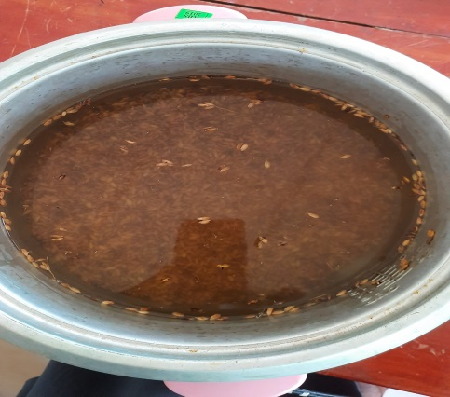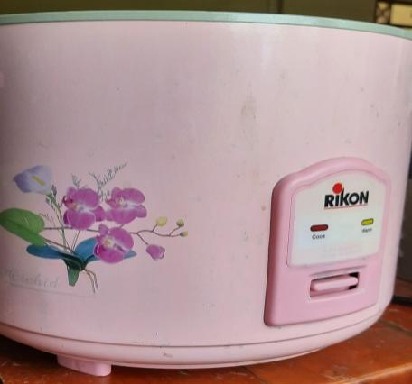
Plate 3.2: soaked steam parboiling of paddy

Pressure soaked steam parboiling
Paddy grains were then steamed under pressure at 5 p.s.I (121⁰C) until their hulls split by using the pressure cooker. For steaming rice was put into the pressure cooker and water was added 1 cm above the paddy. After steaming it was kept for tempering. Then the steamed sample was oven-dried for 3 hours under 60˚C Temperature. (Otegbayo, Osamuel ,et al.2004).
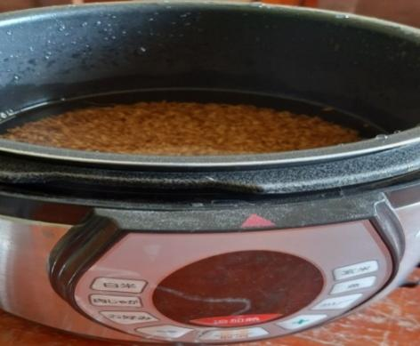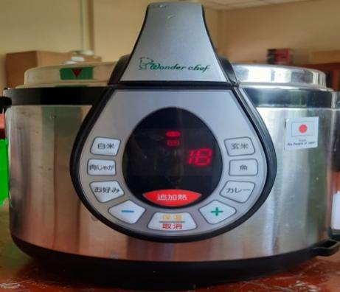
Plate 3.3: Pressure Soaked Steam Parboiling of paddy

Un-soaked steam parboiling
Paddy grains were then steamed till their hulls split off (35.5±0.5%). For this, I have used a rice cooker with a wire mesh steamer. For steaming rice was put on to wire mesh steamer and water was added into cooker then wire mesh steamer was kept above the water. After steaming it was kept for tempering. Then the steamed sample was oven-dried for 3 hours under 60˚C Temperature. (Wimberly 1983, Juliano 1993).
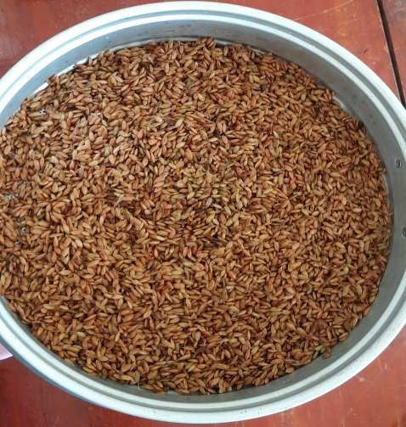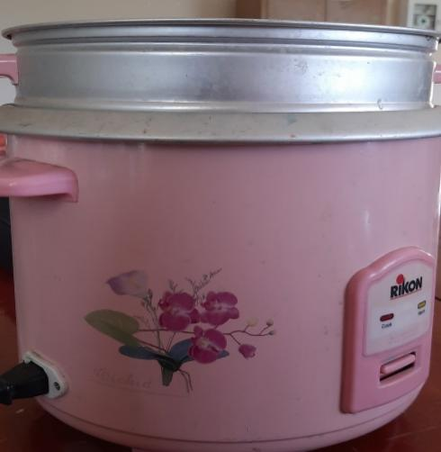
Plate 3.4: Un-soaked Steam Parboiling of paddy

Estimation of milling yield, head rice percentage and, Hardness quality

Milling yield determination
All the samples were de-husked by using a paddy husker at 100 r.p.m. Then all the de-husked samples were winnowed to remove the husk and foreign materials by using a table fan. Then milled paddy was measured and separate the head rice. It was done by using a head rice separator (Satake Engineering Co.Ltd. Tokyo, Japan).
Kernels that should be at least three-fourths of the original kernel length were considered as head rice (USDA, 2005). After separation head rice was weighed by using a weighing balance. Milling yield determination was carried out by using the IRRI formula. The rice was used for the cooking and extrusion test.

Degree of milling and Head rice percentage

The sample of cleaned parboiled paddy 50g was milled by using a paddy husker and, the husk was removed by winnowing then husk, head rice, broken and un-husk paddy was separated and weighed (Fofana et al., 2011).

Degree of milling (%) = $\frac{weight of milled rice}{weight of raw paddy}×100$

Milled rice grains with a length greater than three quarters that of complete grains were considered as head rice, the remainder classed as broken grains (Fofana et al., 2011).
Head rice (%) $=\frac{weight of head rice}{weight of milled rice}$×100

Broken percentage
Milled rice grains with a length less than three-quarters of their normal length were considered as broken rice (Fofana et al., 2011).
Broken (%)$= \frac{weight of broken rice}{weight of rough rice} × 100$

Determination of Resistant starch qualities
Rice Grain Hardness
Rice texture measurement was performed according to a method given. Parboiled rice was rinsed with distilled water three times to remove adhering substances. Rice kernels and distilled water were placed in an automated electric rice cooker (Japan) with different rice-to-water weight ratio. Cooking was for about 20–30 min (as controlled by the automated rice cooker), followed by a 10 min holding period in warm mode. After cooling down to room temperature, cooked rice kernels were positioned centrally under a probe on the base plate. Textural attributes were analyzed (Texture Analyzer) with a 10mm displacement using a, force-versus-distance compression program. Trigger Force (auto), 0.05 N. Texture measurements were conducted for each samples. Outputs were computed.
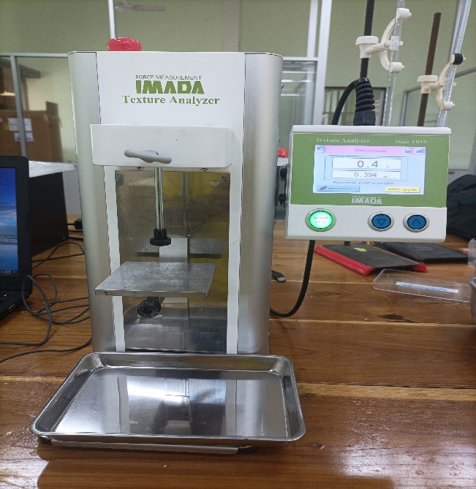
Plate 3.6: Texture analyser

RESULTS AND DISCUSSION

Steaming time with soaking days and Changing of moisture % during drying.
Figure 1, shows the relationship between steaming time (min) and the soaking time (days) of three different parboiling methods. Steaming time decrease as soaking time goes up in all three varieties in all parboiling methods. Considerably Pressure Soaked Steam Parboiling takes less time to steam compared to other methods. Figure 2, shows the relationship between average moisture percentage and drying time. Moisture percentage is decreasing with drying time. For safe storage and a milling moisture percentage of kernels should be less than 12%. To decrease the moisture percentage of kernels it takes 3 hours of time when oven drying at 60˚C Temperature.
Figure.2; Changing of moisture % with drying time

Figure. 1; changes of steaming time with soaking time

Changing of milled rice % with soaking days
Figure 3, 4 & 5 shows the relationship between milled rice percentage and the soaking days of three different rice varieties in three different parboiling methods. Milled rice percentage increases with soaking days in all three varieties in all parboiling methods. According to different soaking conditions parboiling rice show a higher milled rice percentage than control. How-ever rate of such increase in pressure-soaked steam parboiling is higher than other investigated.

.
Figure: 3 Milled rice (HR)% with soaking time (days)
(SSP - Soaked Steam Parboiling, PSSP - Pressure Soaked Steam Parboiling,
OSP - Open steam Parboiling and Without steaming as control.

Figure: 2 Milled rice (HR) % with soaking
SSP - Soaked Steam Parboiling,
PSSP - Pressure Soaked Steam Parboiling,
OSP - Open steam Parboiling and Without steaming as control.

time (days)

Figure: 4 Milled rice (HR)% with soaking time (days)
SSP - Soaked Steam Parboiling,
PSSP - Pressure Soaked Steam Parboiling,
OSP - Open steam Parboiling and Without steaming as control.

Changing of hardness value with soaking time.
Figure 8 shows the relationship between hardness value with the soaking time of three different parboiling methods. Non-steamed samples (control) show a lower hardness value than parboiled rice samples and pressure-soaked steam (PSS) samples show a higher hardness value than other parboiling methods.

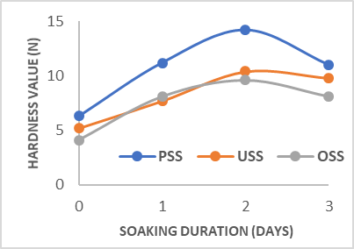

Figure: 8 Hardness value (N) with soaking time (days)
SSP - Soaked Steam Parboiling,
PSSP - Pressure Soaked Steam Parboiling,
OSP - Open steam Parboiling and Without steaming as control.

CONCLUSION
Parboiling increase the head rice yield, resistance starch quality after cooking. Different parboiling methods were practiced to compare three different varieties, At 362, Bg 366, and Adakari have a strong impact on milling yield and resistance starch quality after cooking. Optimum moisture for safe storage and milling steamed paddy samples should be dried up to 3 hr. at 60˚C to reduce moisture percentage beloved 12 by using the convection oven. When consider soaking time, 3 days soaking is optimum because pressure soaked steaming gives a high yield of milling at 2 days soaking time while the other two methods giving a moderate yield of milling at 3 days soaking time. When consider steaming time, pressure-soaked steam parboiling needs less time (20 min) for steaming while soak steam parboiling and un-soaked steam parboiling need more time (30min) that’s why pressure soaked steam parboiling is better than other methods. PSSP is the best method because of less steaming time, less extrusion output with optimum soaking time. Among the investigated parameters involved in this processing commercial variety (Adakari) performed better way in the formation of resistant starch. Different parboiling methods were practiced to compare three different varieties, At 362, Bg 366, and Adakari have a strong impact on milling yield and cooking quality. Parboiling increase the milling yield, head rice yield, cooking quality and decrease the broken rice percentage, Ppressure-soaked steam (PSS) samples show a higher hardness value than other parboiling methods.

REFERENCES
Alexandre, N. (2020) ‘Effect of Parboiling Technique on the Nutritional Quality of Rice’, Global Journal of Nutrition & Food Science, 2(5), pp. 1–13. doi: 10.33552/gjnfs.2020.02.000548.
Behera, G. and Sutar, P. P. (2018) ‘A comprehensive review of mathematical modeling of paddy parboiling and drying: Effects of modern techniques on process kinetics and rice quality’, Trends in Food Science and Technology, 75, pp. 206–230. doi: 10.1016/j.tifs.2018.03.015.
Bello, M. M., Abubakar and Lawan, I. (2015) ‘Rice Parboiling Practices and Technologies in Kano State’, Journal of Engineering and Technology, 10(2), pp. 52–59.
Darandakumbura, H. D. K. et al. (2013) ‘Effect of Processing Conditions and Cooking Methods on Resistant Starch, Dietary Fiber and Glycemic Index of Rice’, Tropical Agricultural Research, 24(2), pp. 163–174.
Fofana, M. et al. (2011) ‘Effect of improved parboiling methods on the physical and cooked grain characteristics of rice varieties in Benin’, International Food Research Journal, 18(2), pp. 715–721.
Islam, R., Shimizu, N. and Kimura, T. (2001) ‘Quality Evaluation of Parboiled Rice with Physical Properties’, Food Science and Technology Research, 7(1), pp. 57–63. doi: 10.3136/fstr.7.57.
Issah, M. H., Appiah, F. and Dery Ninfaa, A. (2015) ‘Effect of Parboiling on the Quality of Processed Degan Rice (Oryza Spp)’, International Journal of Sciences: Basic and Applied Research (IJSBAR) International Journal of Sciences: Basic and Applied Research, 24(3), pp. 153–163. Available at: http://gssrr.org/index.php?journal=JournalOfBasicAndApplied.
Juliano, B. O. (1971) ‘A Simplified Assay for Milled-Rice Amylose’, Cereal Science Today, 16(October 1971), pp. 334–360.
Kumar, S. and Prasad, K. (2013) ‘Effect of Paddy Parboiling and Rice Puffing on Physical, Optical and Aerodynamic Characteristics’, International Journal of Agriculture and Food Science Technology, 4(8), pp. 765–770.
Meresa, A. et al. (2020) ‘Effect of Parboiling Conditions on Physical and Cooking Quality of Selected Rice Varieties’, International Journal of Food Science, 2020. doi: 10.1155/2020/8810553.
Miah, M. A. K. et al. (2002a) ‘Parboiling of rice. Part I: Effect of hot soaking time on quality of milled rice’, International Journal of Food Science and Technology, 37(5), pp. 527–537. doi: 10.1046/j.1365-2621.2002.00610.x.
Miah, M. A. K. et al. (2002b) ‘Parboiling of rice. Part II: Effect of hot soaking time on the degree of starch gelatinization’, International Journal of Food Science and Technology, 37(5), pp. 539–545. doi: 10.1046/j.1365-2621.2002.00611.x.
Oli, P. et al. (2014) ‘Parboiled rice: Understanding from a materials science approach’, Journal of Food Engineering, 124, pp. 173–183. doi: 10.1016/j.jfoodeng.2013.09.010.
Purohit, S. R. and Rao, P. S. (2017) ‘Optimization of paddy parboiling process for higher starch crystallinity by response surface methodology’, International Journal of Biological Macromolecules, 104, pp. 1091–1098. doi: 10.1016/j.ijbiomac.2017.06.089.
Rohman, A. et al. (2014) ‘Rice in health and nutrition’, International Food Research Journal, 21(1), pp. 13–24.
Science, F. (1976) ‘STUDIES ON PARBOILED RICE : PART I - - C O M P A R I S O N OF THE CHARACTERISTICS OF RAW A N D’, (1).
Singh, J. et al. (2018) ‘“Process of paddy parboiling and their effects on rice” A Review’, ~ 1727 ~ Journal of Pharmacognosy and Phytochemistry, 1(October), pp. 1727–1734.
Taghinezhad, E. et al. (2015) ‘Effect of Soaking Temperature and Steaming Time on the Quality of Parboiled Iranian Paddy Rice’, International Journal of Food Engineering, 11(4), pp. 547–556. (doi: 10.1515/ijfe-2014-0296).

