Investigating dietary habits among undergraduate sports persons under low-resource contexts in Sri Lanka
K.U. Ranawaka¹*, G.I.M. Perera¹, K.P.C.A. Tharuka¹, U.B.E. Sanaka ¹
Department of Agribusiness Management, Faculty of Agricultural Sciences, Sabaragamuwa University of Sri Lanka, P.O. Box 70140, Belihuloya, Sri Lanka.
Email: kuranawaka@std.agri.sab.ac.lk

Introduction
Adequate nutrition is an essential factor influencing sports performance, physical recovery, and overall health of athletes. Undergraduate sports persons have higher energy and nutrient requirements compared to non-athletes due to regular training and competitive activities. However, maintaining balanced dietary habits can be challenging, especially in low-resource contexts where financial constraints, limited food availability, and lack of institutional support affect food choices. In Sri Lankan universities, many undergraduate athletes depend mainly on university canteens and nearby food outlets, which may not always provide affordable and nutritionally adequate meals.
Food choice behavior among athletes is influenced by several factors, including cost, convenience, availability, taste preferences, body image concerns, and nutrition knowledge. The Athlete Food Choice Framework (AFCQ) explains how personal, social, and environmental factors interact to shape athletes’ dietary decisions. Although international studies have applied the AFCQ to understand athletes’ food choices, limited research has been conducted in Sri Lanka, particularly focusing on undergraduate sports persons in low-resource university environments.
Sabaragamuwa University of Sri Lanka accommodates a large population of undergraduate sports persons who actively participate in various sports disciplines while managing academic responsibilities. Understanding their dietary habits and food choice factors is important to design effective nutrition interventions and policy improvements. Therefore, the objective of this study was to investigate the dietary habits of undergraduate sports persons under low-resource contexts at Sabaragamuwa University of Sri Lanka using the Athlete Food Choice Framework.

Materials and Methods
A quantitative cross-sectional research design was adopted for this study. The study population consisted of undergraduate sports persons enrolled at Sabaragamuwa University of Sri Lanka. A total of 255 undergraduate athletes were selected using purposive sampling, targeting students actively engaged in university-level sports activities.
Data were collected using a structured, self-administered questionnaire developed based on the Athlete Food Choice Framework. The questionnaire included sections on demographic characteristics, food consumption patterns, low-resource factors, food choice factors, and dietary habits. Prior to the main survey, the questionnaire was pre-tested to ensure clarity, validity, and reliability.
Data analysis was carried out using the Statistical Package for Social Sciences (SPSS). Descriptive statistics such as frequencies, percentages, means, and standard deviations were used to summarize demographic characteristics and food consumption patterns. Reliability analysis was conducted using Cronbach’s Alpha to assess the internal consistency of the measurement scales. Pearson correlation analysis was performed to examine relationships between low-resource factors, food choice factors, and dietary habits. Regression analysis was used to identify the influence of selected food choice factors on dietary behavior of undergraduate sports persons.

Results, Discussion, Conclusion and Recommendations
The study included responses from 255 undergraduate sports persons actively engaged in university-level sports activities. The majority of respondents belonged to the undergraduate age group and represented different academic years and sports disciplines. Most participants reported regular involvement in training sessions and competitions, indicating a physically active lifestyle. A considerable proportion of respondents depended primarily on university canteens and nearby food outlets for their daily meals, highlighting the importance of food availability within the university environment.

Analysis of food consumption patterns revealed that carbohydrate-rich staple foods such as rice were consumed frequently by the majority of respondents. This reflects the common dietary pattern in Sri Lanka, where rice serves as the primary energy source. However, the consumption of protein-rich foods such as meat, fish, eggs, and dairy products was moderate. Intake of fruits and vegetables was also reported at moderate levels, indicating that balanced dietary practices were not consistently followed by all respondents.
Several respondents reported irregular meal patterns, including skipping meals, especially breakfast or lunch. Financial constraints, lack of time due to academic and training commitments, and limited availability of nutritious food options were identified as key reasons for irregular eating habits. These findings suggest that low-resource conditions significantly influence food consumption behavior among undergraduate sports persons.
Reliability Analysis
Reliability analysis was conducted to assess the internal consistency of the questionnaire constructs used in the study. Cronbach’s Alpha values for all major variables, including low-resource factors, food choice factors, and dietary habits, were found to be within acceptable ranges. This indicates that the measurement scales used in the questionnaire were reliable and suitable for further statistical analysis. The results confirm that the data collected were consistent and dependable for examining relationships among study variables.
Correlation Analysis
Pearson correlation analysis was performed to examine the relationships between low-resource factors, food choice factors, and dietary habits. The results showed statistically significant correlations between low-resource factors and dietary habits, indicating that financial limitations and food availability are associated with the eating behavior of undergraduate sports persons. Additionally, food choice factors demonstrated significant relationships with dietary habits, suggesting that personal motivations such as body weight control, convenience, and perceived nutritional value influence food consumption patterns.
These findings highlight that both environmental and personal factors play a role in shaping dietary habits, supporting the relevance of the Athlete Food Choice Framework in explaining food choice behavior among undergraduate athletes.
Regression Analysis
Regression analysis was conducted to identify key predictors of dietary behavior among undergraduate sports persons. The results revealed that food choice factors related to controlling or maintaining body weight had a statistically significant positive effect on protein food consumption. The regression model explained 24.6% of the variation in protein intake, indicating a moderate explanatory power.
This result suggests that undergraduate sports persons who are more concerned about body weight and physical fitness are more likely to consume protein-rich foods. The regression findings emphasize the importance of food choice motivations in determining dietary behavior, even under low-resource conditions. However, the remaining unexplained variation indicates that additional factors, such as cultural preferences, nutritional knowledge, and institutional support, may also influence dietary habits.

In conclusion, the study confirms that dietary habits of undergraduate sports persons at Sabaragamuwa University of Sri Lanka are strongly influenced by low-resource conditions and food choice factors. The Athlete Food Choice Framework was found to be a useful model for understanding dietary behavior in a university sports environment. Improving access to affordable nutritious food, introducing nutrition education programs, providing institutional support, and implementing nutrition-friendly university policies are recommended to enhance the dietary practices and overall well-being of undergraduate sports persons.

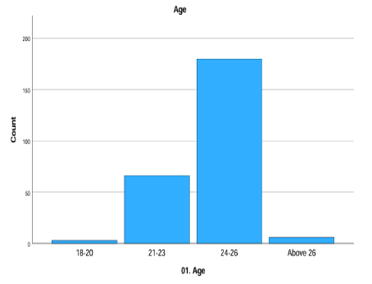
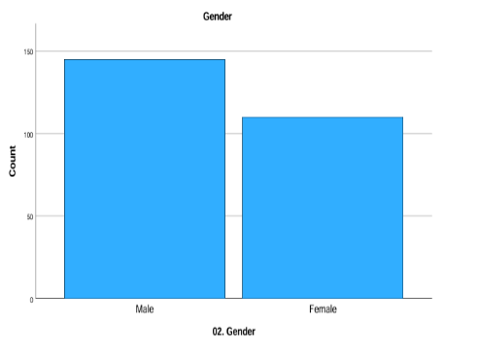

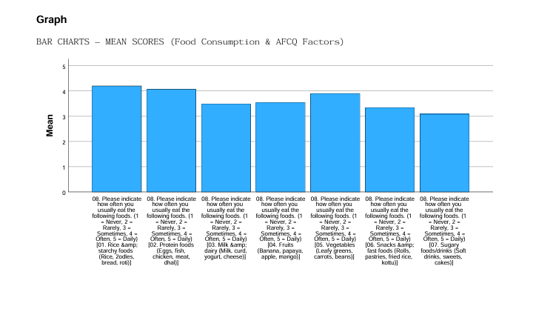
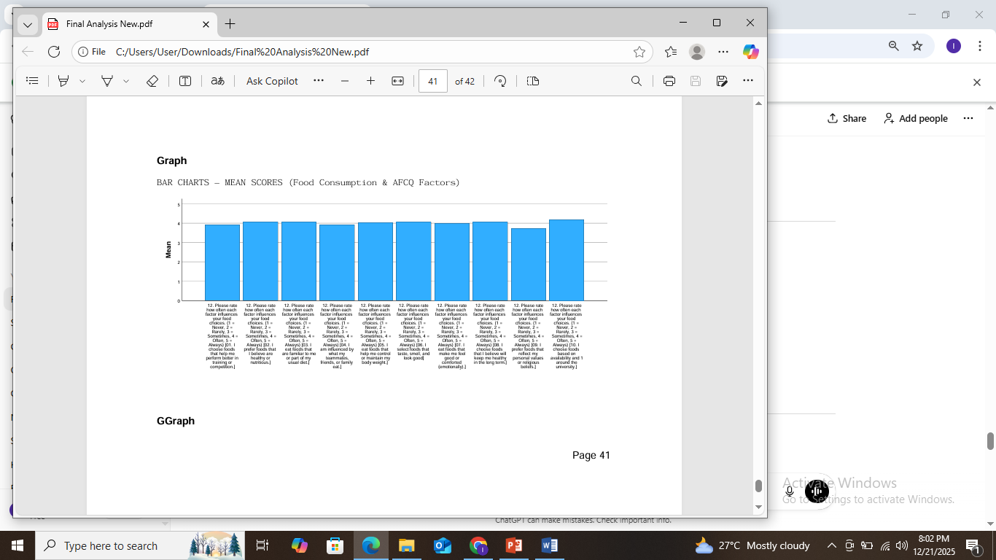




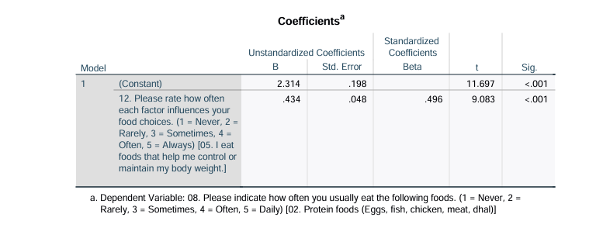


References
Birkenhead, K.L. and Slater, G., 2015. A review of factors influencing athletes’ food choices. Sports Medicine, 45(11), pp.1511–1522.
Pelly, F.E. and Thurecht, R.L., 2019. Evaluation of athletes’ food choice framework. Appetite, 133, pp.156–163.
Thomas, D.T., Erdman, K.A. and Burke, L.M., 2016. Nutrition and athletic performance. Journal of the Academy of Nutrition and Dietetics, 116(3), pp.501–528.
World Health Organization, 2020. Healthy diet. Geneva: WHO.
Dunn, M., Turner, L. and Denny, G., 2017. Food choices of elite athletes. International Journal of Sport Nutrition and Exercise Metabolism, 27(4), pp.335–345.

