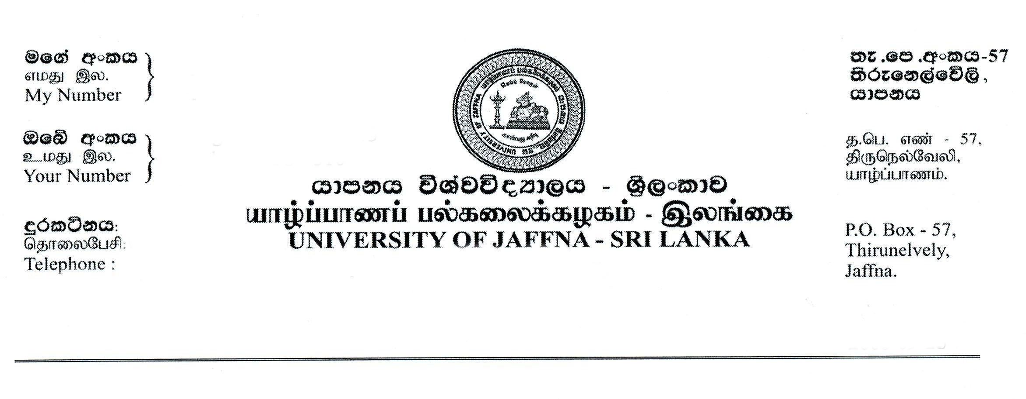
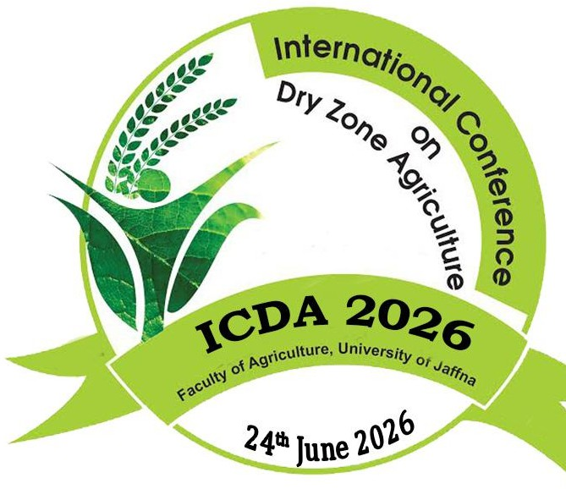

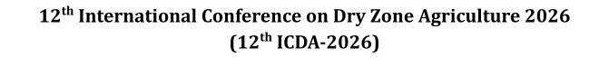


Author(s) Consent form- ICDA 2026

- We undersigned declare and acknowledge that:
  - We have authored/co-authored or supervised the research work entitled
Development of a Gluten-Free Fibre- and Iron-Rich Snack Bar Using Palmyrah Tuber Flour.

  - I/We agreed to submit the above research work to the 12th International Conference on Dry Zone Agriculture (ICDA) 2026 organized by the Faculty of Agriculture, University of Jaffna
  - The abstract submitted for ICDA 2026 reports original research carried out by the authors mentioned and has not been published or submitted for publication elsewhere. Further we understand that the editor’s decision is final on the outcome of the publication.
  - If the manuscript is accepted for an oral presentation, Faculty of agriculture, University of Jaffna has the right to publish in the 12th ICDA proceeding
  - The research remains the intellectual property of the authors, who are entitled to submit it for the publication in other journals or Journal of Dry Zone Agriculture published by Faculty of Agriculture, University of Jaffna

- Preferred sub theme(s) for submission:
1. | Food Science and Nutrition

- Names and signatures of authors in the order they appear in the abstract:
 | Authors Name | Signature | Date
1. | S. Luxcika | 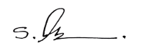 | 12/31/2025
2. | T. Kirushanthi | 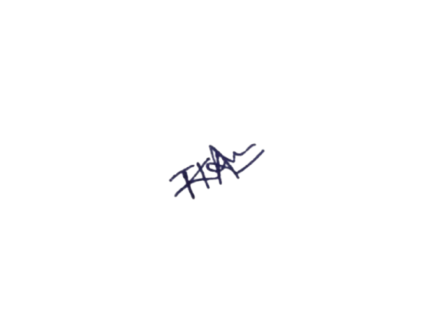 | 12/31/2025
3. | Dr. P. Wattage | Prem Wattage. | 12/31/2025
Add additional authors by insertion

- Contact details of Co-responding author:
Full Name: | Luxcika Sunthararaja
Official Address: | No – 223 5th Cross, Barathy Puram, Kilinochchi.
Email Address: | 10lux20mar@gmail.com
T. Number (Mobile): | 0764109242
Signature:

All authors must sign the consent form for the consideration of the research work to ICDA 2026

